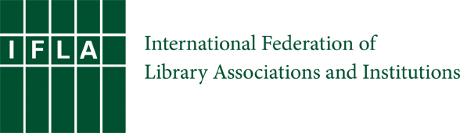

IFLA Green Library Award 2017

Application Form
Administered by ENSULIB
IFLA’s Environment, Sustainability and Libraries Special Interest Group
www.ifla.org/environmental-sustainability-and-libraries

Sponsored by de Gruyter

Submission title
Submission type | ( ) essay, ( ) video, ( ) poster, ( ) article, ( ) set of slides,  ( ) other: ______________________________________
Submission language | ( ) Arabic, ( ) Chinese, ( ) English, ( ) German, ( ) French,  ( ) Russian, ( ) Spanish
Surname(s), name(s)
Institution
Postal address
Email
Website
Description (300 words):

Please send your submission (essay, video, poster, article, set of slides, others) only electronically as an attachment, via Dropbox etc. not later than 30 April 2017 to:
Dr. Petra Hauke, ENSULIB secretary
Berlin, Germany, Email: petra.hauke@hu-berlin.de

