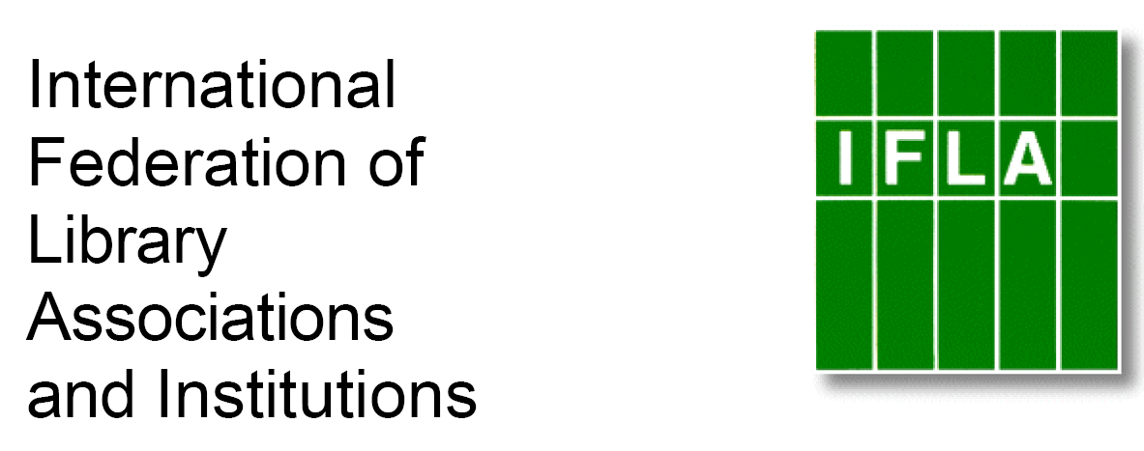

SISTER LIBRARIES FOR CHILDREN’S READING
REGISTRATION FORM

Please email completed forms to ian_yap@nlb.gov.sg

Bold Sections : Necessary information
Normal Sections : Optional information

Type of institution : Secondary co-ed private catholic school
(eg. public library, school library, other institutions…)

Contact person : Debbie Northway

Title : Teacher Librarian

Email : dnorthway@bne.catholic.edu.au

Library or institution name : Andre Michels Library, St Peter Claver College

Address :
10 Old Ipswich Road
Riverview QLD 4303
Australia

Postal address (if different from above) :
PO Box 6016
Riverview QLD 4303
Australia

Country : Australia

Phone : 07 3810 5900

Fax : 07 3282 3190

Email : sriverview@bne.catholic.edu.au

Website : http://www.spcc.qld.edu.au/

Languages librarians speak : English

Languages children and young adults speak/read : English -

Number of members (children and young people) : 940

Number of children and young people visiting the library per week (members and non members) : All classes

Number of documents (total collection) for children and YA : books, press, others (audio CDs, DVDs, CDRoms…) : n/a

Staff of the children’s section, employees and volunteers : Teacher Librarian, Library assistant, IT team of 3.

Current library programs for children and young adults : Classroom support, learning management system, book and creative writing club.

Countries (for partnership) Preferred :

Reasons for wanting a Sister Library relationship : To exchange ideas and resources, to connect our students to the rest of the world and create a more global view of people and information. To learn, share information and to be creative!

