**Mr José Barroso,** President of the European Commission

**Ms Neelie Kroes,** Vice-President of the European Commission

**Ms Máire Geoghegan-Quinn,** Research, Innovation and Science Commissioner

**Mr Michel Barnier**, Internal Market and Services Commissioner

**Ms Androulla Vassiliou,** Education, Culture, Multilingualism and Youth Commissioner

Greek Presidency and Members of the Council of the European Union

Members of the European Parliament

**Fulfill the promise of the Innovation Union: European research institutions, libraries and archives need balanced copyright laws**

Copyright exceptions and limitations for libraries and archives are currently being discussed by the World Intellectual Property Organisation (WIPO) Standing Committee on Copyright & Related Rights (SCCR). The undersigned organisations feel they must express their deep disappointment following the European Union’s unwillingness to progress text-based discussions on this topic at the last meeting of the SCCR. In doing so, the European Union tried to reverse conclusions that had been previously agreed by all of the world’s countries at WIPO.

The undersigned European and international research institutions and library and archive organisations strongly urge the European Union and its Member States to ensure that text-based discussion of an international instrument on copyright exceptions and limitations for libraries and archives continues to be reflected in the mandate of the SCCR, and that the European Union engages constructively in these discussions. These discussions are important to:

1. **Foster a cutting-edge, open international research culture**

The European Union has identified **international research and development collaboration** as key to the success of the Innovation Union and the Europe 2020 initiative. Indeed, European countries are leading the world for international co-authorship.[1] European research institutions need a research infrastructure that is *globally oriented* and supports seamless access to information *across national borders,*[2] outside as well as within the EU.

The EU has also identified open access to research outputs as key for Europe as a means of supporting a more collaborative and open way to do science. Researchers are using new tools and methods to support research outputs, and copyright laws should facilitate, not stifle, this. The talks at WIPO potentially will enable the world’s libraries and archives to facilitate measured and reasonable access to their own cultural and scientific collections for the benefit of European citizens and researchers.

1. **Ensure future researchers have access to our digitized and born-digital heritage**

**70% of total global journal publishing revenues are generated from academic library subscriptions**.[3] Despite libraries being the single biggest purchaser of scholarly publications, future researchers are in danger of being unable to access significant portions of our 20th and early 21st century digital heritage. Access to information in the digital environment is increasingly restricted by licensing and digital locks, which prevent libraries and archives from being able to preserve culture and research outputs for the future. National approaches to this problem fall short, because the digital information that researchers are accessing is now global.

1. **Make European cultural heritage globally accessible**

European libraries and archives possess rich collections that are important for the research and study of history and culture within Europe, and its historical influence on other cultures and societies. Today populations are mobile and multicultural. The internet holds the promise for libraries and archives to provide access to Europe’s collections globally, and to enable Europeans to access culturally important materials held by libraries and archives outside Europe, thereby enhancing global scholarship and learning.

**The copyright challenges for libraries and archives**

Copyright laws stop at the national border, both within the European Union and elsewhere, frustrating the efforts of libraries and archives whose mission is to ensure that people, regardless of their location and regardless of their means, have the potential to access Europe’s culture, history and scientific research. The European Union’s strong objection to text-based discussions of copyright exceptions and limitations at WIPO is particularly concerning in light of the Commission’s own ongoing consultations about updating Europe’s copyright laws, to better serve its Single Market.

The aspirations of the Internal Single Market are to support innovation, increase productivity, ensure the seamless flow of information and access to knowledge within EU borders, as well as encourage the creation of new copyright-protected works. Robust copyright exceptions and limitations are essential to this.

**The international copyright framework is not working**

The European Union has stated at SCCRs that the existing international copyright framework provides sufficient policy space for domestic copyright exceptions and limitations for libraries and archives [[link]](http://register.consilium.europa.eu/doc/srv?l=EN&f=ST%209677%202014%20INIT). Libraries, archives and research institutions at the most recent meeting of the SCCR provided ample illustrations of the challenges they face in the cross-border internet environment, where national exceptions are no longer enough [[link]](http://blogs.ifla.org/sccr/). In short:

* Under the existing treaties, copyright protections are **mandatory** while copyright exceptions are **optional**. This entrenched imbalance results in a patchwork approach to copyright exceptions in domestic copyright laws, with the public interest in education, scholarly research and innovation, and cultural preservation de-valued, in contrast with private interests.
* Increasingly, national copyright exceptions do not apply for libraries and archives. Licence terms set by publishers, often from other countries, override many exceptions in domestic copyright laws, and these terms can vary widely from licence to licence.
* This patchwork of national exceptions and the complexity of the licensing environment are frustrating international research collaboration, and placing libraries and archives in an ambiguous position as they try to lawfully fulfill their mission.

The undersigned organisations believe that a balanced and effective international copyright framework should support robust discussion of exceptions and limitations to copyright, as well as protections for creators. **This can only be to everyone’s benefit.** We ask the European Union to continue discussions of international copyright exceptions and limitations for libraries and archives at WIPO in good faith, and progress Committee work towards an international solution.

Yours sincerely,

[list of signatories on the next page]

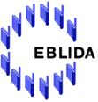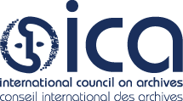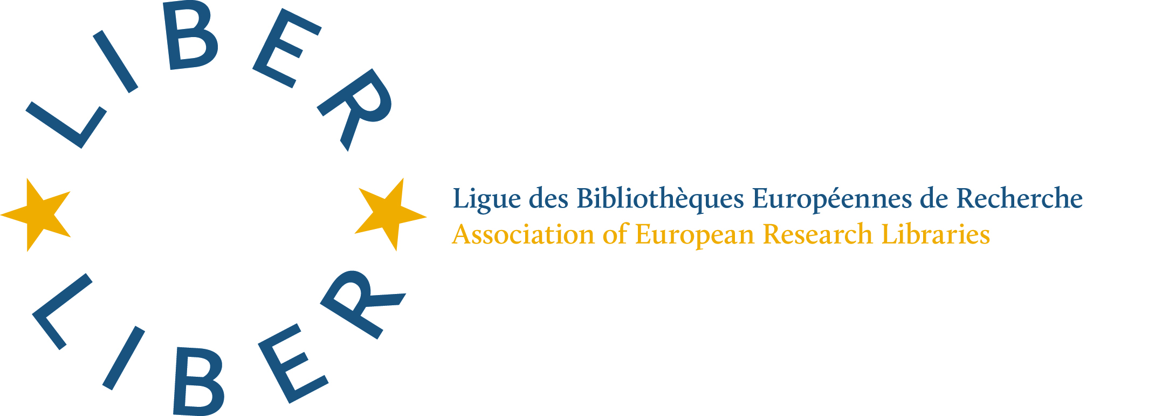

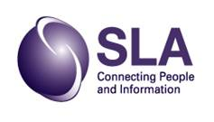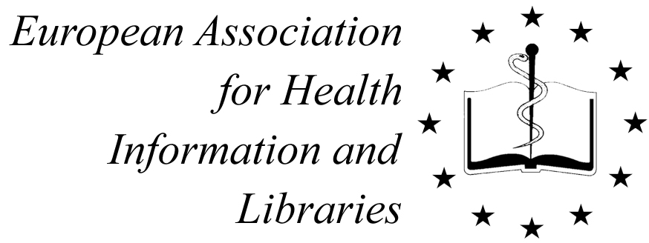

And:

* [Scottish Council on Archives](http://www.scottisharchives.org.uk/) (SCA)
* [Chartered Institute of Library and Information Professionals](http://www.cilip.org.uk/) (CILIP) (UK)
* [European Bureau of Library Information and Documentation Associations](http://www.eblida.org/) (EBLIDA)
* Poznańska Fundacja Bibliotek Naukowych |[Poznan Foundation of Scientific Libraries](http://www.pfsl.poznan.pl/en) (Poland)
* Stowarzyszenie EBIB |[EBIB Association](http://strony.nowyebib.info/stowarzyszenie/home) (Poland)
* [City of Malmo Public Library](http://www.malmo.se/stadsbibliotek) (Sweden)
* [Karisma Foundation](http://karisma.org.co/) (Colombia)
* [Federación Española de Sociedades de Archivística, Biblioteconomía, Documentación y Museística](http://www.fesabid.org/) (FESABID) (Spain)
* [Svensk Biblioteksförening](http://www.biblioteksforeningen.org/) (Sweden)
* [University of Westminster](http://www.westminster.ac.uk/) (UK)
* Lithuanian College Library Association
* [Universitat Politècnica de Catalunya • BarcelonaTech](http://www.upc.edu/?set_language=en) (UPC) (Spain)
* [Mykolas Romeris University](http://www.mruni.eu/en/) (Lithuania)
* [Lithuanian Library for the Blind](http://www.labiblioteka.lt/en/) (Lithuania)
* [The Libraries and Archives Copyright Alliance](http://www.cilip.org.uk/cilip/advocacy-awards-and-projects/advocacy-and-campaigns/copyright/laca-libraries-and-archives) (LACA) (UK)
* [ANABAD-Aragon](http://www.anabad.org/ut-aragon.html) (Bibliotecas, Archivos, Centros de Documentación y Museos en la Comunidad Autónoma de Aragón) (Spain)
* [Lithuanian Research Library Consortium](http://www.lmba.lt/en) (LMBA)
* [Bibliothèque nationale et universitaire, Strasbourg](http://www.bnu.fr/en/) (France)
* [University of Kent](http://www.kent.ac.uk/) (UK)
* [Australian Library & Information Association](https://www.alia.org.au/) (ALIA)
* [Australian Libraries Copyright Committee](http://libcopyright.org.au/) (ALCC)
* [University of St Andrews Library](http://www.st-andrews.ac.uk/library/) (UK)
* [Stowarzyszenie Bibliotekarzy Polskich](http://www.sbp.pl/en) | *Polish Library Association*
* [Biblioteca de la Universidad del País Vasco](http://www.biblioteka.ehu.es/) / Euskal Herriko Unibertsitatea (Spain)
* [Universidad de Almeria](http://cms.ual.es/UAL/universidad/serviciosgenerales/deportes/index.htm) (Spain)
* [Siauliai county Povilas Visinskis public library](http://www.savb.lt/en/) (Lithuania)
* [University of Extremadura](http://www.unex.es/conoce-la-uex/estructura-academica/centros/veterinaria/contenido_portlets_configurables/car_20090327_001/car_20090327_006/informacion-varia/doc_20100225_001) (Spain)
* [Klaipeda County Ieva Simonaityte Public Library](http://www.klavb.lt/en/) (Lithuania)
* [Vereinigung Österreichischer Bibliothekarinnen und Bibliothekare](http://www.univie.ac.at/voeb/php/) |Association of Austrian Librarians
* [National Library of the Czech Republic](http://www.en.nkp.cz/)
* [Middlesex University London](http://www.mdx.ac.uk/)
* [Moravská zemská knihovna v Brně](http://www.mzk.cz/) (Moravian Library Brno) (Czech Republic)
* [Kaunas College](http://www.kaunokolegija.lt/) (Lithuania)
* [CRAI Universitat de Barcelona](http://www.bib.ub.edu/en/) (Spain)
* [German Library Association](http://www.bibliotheksverband.de/)
* [Památník národního písemnictví](http://www.pamatniknarodnihopisemnictvi.cz/) (Czech Republic)
* [Research Institute of Geodesy, Topography and Cartography](http://www.vugtk.cz/) (Czech Republic)
* [Municipal Library Chodov](http://www.knihovnachodov.cz/) (Czech Republic)
* [Ufficio di Biblioteca dei dipartimenti di Area Medica](https://www.med.unipmn.it/biblioteca) (Italy)
* [Kolping University of Applied Sciences](http://kolegija.kolping.lt/about-us/) (Lithuania)
* [Kaunas County Public Library](http://www.kvb.lt) (Lithuania)
* [Biblioteca "Water Bigiavi" - Università di Bologna](http://biblioteche.unibo.it/bigiavi) (Italy)
* [National Medical Library](http://www.nlk.cz/) (Czech Republic)
* [Slovak Librarians and Libraries Association](http://www.infolib.sk/sk/spolok-slovenskych-knihovnikov-kniznic/) |Spolok slovenských knihovníkov a knižníc (Slovakia)
* [Austrian Library Association](http://www.bvoe.at/en) | Büchereiverband Österreichs
* [Šiauliai State College](http://www.svako.lt/en) (Lithuania)
* [University of Library Studies and IT (UniBIT)](http://www.unibit.bg/en)  (Bulgaria)
* The Library of the city Olomouc (Czech Republic**)**
* Kauno technikos kolegija | [Kaunas University of Applied Engineering Sciences](http://www.ktk.lt/cgi-bin/svetaine.pl?nr=0&kalba=3) (Lithuania)
* [Krajska Knihovna v Pardubiich](http://kkpce.cz/cs/) (Czech Republic)
* [Electric Library Consortium of Armenia](http://www.eifl.net/armenia/) (ECLA)
* Lithuanian Library of Medicine
* [National Library of Lithuania](http://www.lnb.lt/)
* North Bohemian Research Library (Czech Republic)
* [Siauliai University Library](http://biblioteka.su.lt/en/) (Lithuania)
* [National Electronic Information Consortium](http://www.neicon.ru/) (NEICON) (Russia)
* Municipal Library of Opočno (Czech Republic)
* [Canadian Library Association](http://www.cla.ca/) (CLA)
* Technical University of Liberec Library (Czech Republic)
* [Slovenian Library Association](http://www.zbds-zveza.si/eng/?q=node1/1)
* [Associazione Italiana Biblioteche](http://www.aib.it/)
* [Università di Napoli “Parthenope” – Biblioteca central](http://biblioteca.uninav.it/) (Italy)
* [Latvian Librarians Association](http://www.lnb.lv/en/librarians/latvian-librarians-association)
* Network for InterLibrary Document Exchange (NILDE)
* [Svaz knihovníků a informačních pracovníků České republiky](http://www.skipcr.cz/) - Association of Library and Information Professionals of the Czech Republic (SKIP)
* [Associazione Nazionale Archivistica Italiana](http://www.anai.org) (Italy)
* [Universidad Politécnica de Cartagena](http://www.upct.es/) (España)
* Università degli Studi di Genova Dipartimento di Giurisprudenza (Italy)
* Knihovna Kroměřížska (Czech Republic)
* [Mondragon Unibertsitatea Library](http://www.mondragon.edu/es/biblioteka) (Spain)
* [Konferencja Dyrektorów Bibliotek Akademickich Szkół Polskich](http://kangur.uek.krakow.pl/kdbasp/) | Conference of Heads of Academic Libraries in Poland
* Universidad Nacional de Educación a Distancia Biblioteca (Spain)
* [National and State Libraries Australasia](http://www.nsla.org.au/) (NSLA)
* [Canadian Association of Professional Academic Librarians](http://capalibrarians.org/) (CAPAL)
* [BibloRed, Bogotá Public Libraries Network](http://www.biblored.gov.co/) (Colombia)
* Universidad de Córdoba (Spain)
* The Karel Dvořáček Library | Knihovna Karla Dvořáčka, Vyškov (Czech Republic)
* [International Association of Music Libraries, Archives and Documentation Centres, UK and Ireland](http://www.iaml.info/iaml-uk-irl/) (IAML)
* Società Napoletana di Storia Patria (Italy)
* Universitat Pompeu Fabra Library (Spain)
* National Library Association of Uruguay
* [European Network for Copyright in Support of Education and Science](http://www.ences.eu/) (ENCES)
* [De Montfort University, Leicester](http://www.dmu.ac.uk/home.aspx) (UK)

1. As on 2012, France was ranked number 1 in the world for international co-authorship (50.0%), followed by the United Kingdom with 47.6%: <https://www.gov.uk/government/uploads/system/uploads/attachment_data/file/263729/bis-13-1297-international-comparative-performance-of-the-UK-research-base-2013.pdf>
2. A recent study identified 253 cross-border higher education programs (covering only branch campuses or franchising agreements) operating in the EU: <http://ec.europa.eu/education/library/study/borders_en.pdf> p. 38.
3. Ware, M, The STM Report: An Overview of scientific and scholarly journal publishing, <http://www.stm-assoc.org/2012_12_11_STM_Report_2012.pdf> (page 19).