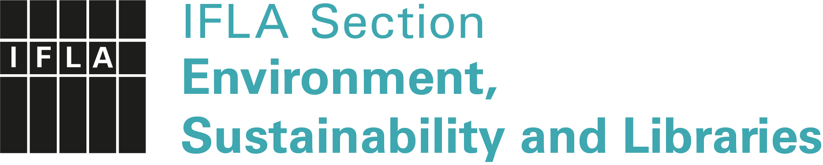

IFLA Green Library Award 2021

Application Form
Administered by ENSULIB, IFLA Section on Environment, Sustainability and Libraries
https://www.ifla.org/environment-sustainability-and-libraries

Sponsored by de Gruyter Publishing House

Submission title
Numbers of SDGs addressed
Submission type | ( ) essay, ( ) video, ( ) poster, ( ) article, ( ) set of slides,  ( ) other: ______________________________________  Concerning ( ) an entire library or ( ) a project
Submission language | ( ) English, ( ) Arabic, ( ) Chinese, ( ) German, ( ) French,  ( ) Russian, ( ) Spanish – all with English abstract (required)
Surname(s), name(s)
Institution
Postal address
Email
Website
Description (not more than 300 words):

Please send your submission only electronically as an attachment, via Dropbox, WeTransfer etc. not later than 28 February 2021 to:
Dr. Petra Hauke, ENSULIB Secretary
Email: petra.hauke@hu-berlin.de

