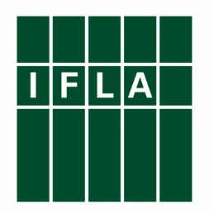
Application Form for Shawky Salem Conference Grant 2019

Dr. Shawky Salem Conference Grant for Arab Specialists in Library and information Sciences (LIS) to attend the World Library and Information Congress: IFLA General Conference and Assembly.

The undersigned wishes to be considered as a candidate for Dr. Shawky Salem Grant by supplying the information requested below.

Family Name:
First Name and other names:
Date of Birth: | Gender:
Institution:
Address:

Country:
Highest Level of Formal Education (Ph.D., M.A., B.A., etc):
Professional Experience (Years):
Have you attended the IFLA Congress before?
E-mail: | Fax:
I agree to IFLA’s use of my personal data for grant purposes only. IFLA will keep the data during the grant selection process, after which it will be deleted or destroyed. For further information on IFLA’s compliance with data protection laws, please see IFLA’s Data Protection Policy.

This form must be written and accompanied by the following documents in English or Arabic:
- Motivation letter (max 1 page) explaining the reasons for applying and showing how your home country / library community will benefit from your participation in IFLA Congress
- Applicant’s CV (max 2 pages) including an outline of higher education degrees, work experience (full time / part time), association memberships and spoken languages
- Recommendation letter from your organisation (max 1 page) including the length of your employment and a statement of support for attendance at the IFLA Congress.

The application form should be submitted by email before 31 March 2019: grants@ifla.grant
My signature indicates that all information in my application is complete, factually correct, and honestly presented.

Signature: Date:

