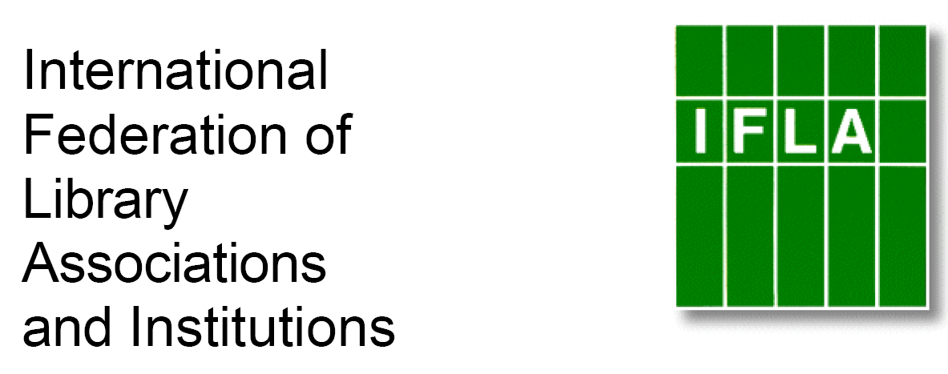

SISTER LIBRARIES FOR CHILDREN’S READING
REGISTRATION FORM

Please email completed forms to ian_yap@nlb.gov.sg

Bold Sections : Necessary information
Normal Sections : Optional information

Type of institution : Public Library
(eg. public library, school library, other institutions…)

Contact person : Robin Gibson

Title : Youth Services Librarian

Email : rgibson@westervillelibrary.org

Library or institution name : Westerville Public Library

Address : 126 South State Street, Westerville, OH 43081

Postal address (if different from above) :

Country : USA

Phone : 614/882-7277 ext. 5006

Fax :

Email : rgibson@westervillelibrary.org

Website : http://www.westervillelibrary.org

Languages librarians speak : English, French, Spanish, German

Languages children and young adults speak/read : English

Number of members (children and young people) : 102,264 cardholders (total, not just children; population of service are is 86,000).

Number of children and young people visiting the library per week (members and non members) :

Number of documents (total collection) for children and YA : books, press, others (audio CDs, DVDs, CDRoms…) : 310,555 (total collection, not just children’s)

Staff of the children’s section, employees and volunteers : 7 full time librarians, 2 part time librarians, plus an active group of teen volunteers

Current library programs for children and young adults : Storytimes for babies through preschoolers, after school programs, book club for 4th and 5th graders and teen book club, additional special programs, theatre workshops, Saturday Tales (an ongoing family storytime), storytimes for preschools and visits to local schools.

Countries (for partnership) Preferred : no strong preference; need to speak or read English

Reasons for wanting a Sister Library relationship: We would like to exchange ideas for programs and discuss books with other children’s librarians. We would like to start with a small project, such as exchanging emails and possibly Skyping. We would like to involve children and for them to have the opportunity to exchange letters or emails and possibly talk with other children about books and life in another country. We are excited about learning about another country and culture through an informal exchange between librarians and children in both communities.

