Libraries Serving Persons with Print Disabilities – LPD

Newsletter 01/2020

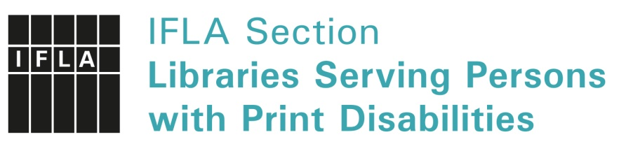
Welcome

LPD welcomes you back to the Newsletter!
In 2018 – 2019, we have had a break in publishing the LPD Newsletter. Hopefully, you have discovered our social media channels, Facebook group and Twitter in the meantime. [links to FB and Twitter]
This time of pandemic has caused many cancellations of conferences and meetings. Unfortunately, IFLA WLIC 2020 also has been cancelled.
We hope that this newsletter will provide you with interesting and useful information.
LPD has been lobbying for the implementation of the Marrakesh Treaty which aims to make more accessible books available for persons with print disabilities. We are delighted that nearly 100 countries have contracted the Marrakesh Treaty. The latest countries are Serbia (into force May 24), Tanzania (July 8) and Vanuatu (August 6, 2020).
In this newsletter we are happy to present more news about the implementation of the Marrakesh Treaty around the world. You can read about new developments in the Accessible Books Consortium (ABC) and at ONCE (Spain) and its new international service. We also give an overview of what is going on in Argentina and Latin America.
I wish you all good health and happiness! Enjoy this newsletter,
Kirsi Ylänne, LPD Chair
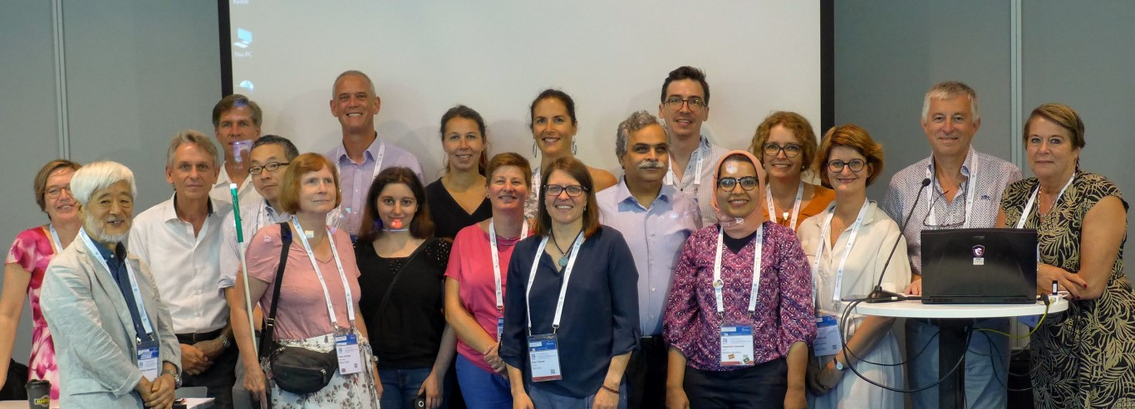
Members of the section at the IFLA WLIC 2019 in Athens. Chair Kirsi Ylänne in the middle, first row.

Preface
Libraries Serving Persons with Print Disabilities (LPD): those Services are rare, mostly there is only one public funded institution in a country. Each institution is doing as much as possible to serve people in the right way.
How we organize the services differs a lot, but what we offer often is the same. We have DAISY, we have braille, we may have tactile graphics, we may have large print or e-books. We need accessible catalogues, metadata to share the titles, services to reach out to the people, devices and technical development to use accessible formats. Working within the LPD gives us the chance to share knowledge, share books on the base of the Marrakesh Treaty and work together on common topics.
As the new information coordinators of LPD, we want to give you the chance to do all that. We decided to revitalize the newsletter to spread topics of the LPD work and – doing so - to connect people. Now it is up to you to contribute and work together. Please tell us about what you are working on: it may help libraries next door or at the other side of the world!
So we are already working on the forthcoming items and we can promise: the next newsletter will arrive in October 2020.
More information about the LPD section: www.ifla.org/lpd. Furthermore you can easily come up with your items writing an email to: c.felsmann@dzblesen.de.
About us
Christiane Felsmann, information coordinator: Head of Library Services and Costumer Relationship at the German Centre of Accessible Reading, Leipzig, Germany. Member of the LPD Standing Committee since 2015. Member of the Commission of user oriented Services of the German library association.
Saskia Boets, assisting: Head of Communications and Operational Manager of Luisterpuntbibliotheek, the Flemish library serving persons with a print disability, Belgium. Member of the LPD Standing Committee since 2019, corresponding member 2017-2019.
Christiane Felsmann, Saskia Boets

ABC Global Book Service Expands to 575,000 Titles
The Accessible Books Consortium’s (ABC) Global Book Service has passed a major milestone, with over 575,000 accessible works now available for cross-border, clearance-free exchange to benefit people who are print disabled.
WIPO’s ABC Global Book Service is an online catalogue for the international exchange of accessible books by 71 participating libraries for the blind, which are able to increase the size of their collections free-of-charge with accessible books obtained through ABC under the provisions of the Marrakesh Treaty to Facilitate Access to Published Works for Persons Who Are Blind, Visually Impaired, or Otherwise Print Disabled.
Under the terms of the Marrakesh Treaty, books in accessible formats – such as Braille, e-text, audio or large print – may be produced and exchanged across borders without the need to request permission from the copyright owner. The ABC and its Global Book Service support the implementation of the objectives of the Marrakesh Treaty at a practical level.
The expansion was possible due to the collections of four participating Swiss libraries for the blind, covering 23,000 titles primarily in French, German and Italian, becoming available for cross-border exchange under the provisions of the Marrakesh Treaty, which were recently implemented in Switzerland.
For those participating libraries in ABC that are located in countries that have not yet ratified and implemented the provisions of the Treaty, ABC also has over 29,000 titles with permissions granted by the copyright owner allowing for cross-border exchange around the world.
The Marrakesh Treaty is WIPO’s fastest growing treaty and currently has 67 contracting parties covering 94 countries, since the European Union joined as one block.
ABC also has over 20 additional libraries for the blind that have confirmed their intention to join the Service, which will make this a truly comprehensive global catalogue of accessible books.
Libraries that are interested in joining the ABC Global Book Service can contact the ABC Secretariat at Accessible.Books@wipo.int. There are no membership fees or costs to join.
For further information, please visit www.AccessibleBooksConsortium.org.

By Monica Halil Lövblad, Head, ABC

ONCE – New library services
On October 8th, 2019, at the Cervantes Institute in Madrid, the National Organization of Spanish Blind persons (ONCE) presented to the world its new digital library, which not only looked nicer than before but also included some fundamental changes in how and by whom it could be accessed in the future.
Knowledgeable of the consequences of the entry into force of the Marrakesh Treaty in the European Union (and, subsequently, also in Spain) on the first day of 2020, ONCE’s library service had spent the better part of the previous year preparing for this new milestone in our 80-year-long history. After actively fighting for the Treaty – as part of the World Blind Union negotiation team – both at WIPO’s Headquarters in Geneva and in Marrakesh itself, time had come for ONCE to put our library where our mouth was. After studying various options, we decided to take a dual approach that would benefit both our users and those institutions providing services to blind and visually impaired persons all around the world – i.e., opening up our members-only digital library and joining the ABC Global Book Service.
In order to open our holdings to the world in a time- and cost-efficient way, we decided to make use of our existing digital library rather than designing and building a new one. The current online library had been used by our users for more than a decade with great success, having widely proved its usability and accessibility. This digital library had to be, before January 1st, exclusive to ONCE members, following the pre-Marrakech copyright regulations. However, the provisions of the Treaty would allow us now to grant access to our extensive library to institutions and individuals in other “Marrakech countries”.
This book collection comprises more than 64,000 high-quality titles in Spanish, including books in braille and Daisy, plus 3,000 braille scores. All of these titles are in electronic form and can be downloaded directly by anyone with a username and a password. Initially, the service has been restricted to participating institutions and libraries only, leaving direct access to non-ONCE individuals for a later stage. Getting your library credentials is probably the most time-consuming part of the process, as we have to make sure that your institution and your country meet the required legal requirements stated both in the Treaty and in the EU Directive and Regulation. Recently, after talks with our Ministry of Culture, it was decided that, to speed up the process, institutions whose status had been already clarified by WIPO as members of the ABC book service would be granted access to our library in a more straightforward way. The first European library to join our online library is also a member of the LPD Standing Committee – Luisterpuntbibliotheek, from Belgium. If your institution is interested in becoming part of it, you can contact our Marrakech Office at marrakech.sbo@once.es.
Giving access to our users to titles produced by other agencies and libraries in other languages was our second priority. To do so, ONCE joined the ABC Global Book Service at the end of 2019, a free online service provided by WIPO to all libraries that hold and/or produce works in accessible formats. This has allowed us to start building our own collection of braille and audio titles in foreign languages and to fulfill our users’ requests for specific titles. ONCE has contributed nearly 35,000 Daisy titles to the 620,000 titles in more than 80 languages that ABC manages, and we are in the process of incorporating our braille catalogue, including all our braille music scores. This means that members of ABC can now request titles from ONCE either via the ABC platform or by joining our online digital library. So far, Celia (Finland) and the NLS (United States) – both members of the LPD IFLA section – have already received Daisy books from us using the ABC service, together with the Fundación Braille del Uruguay and INCI, from Colombia. We are delighted to see all these long-time friends benefitting from a library we had to keep for ourselves for 55 years due to the restrictive copyright regulations we had before the Treaty. We hope to see more old and new friends taking advantage of this global achievement.
The entire process has taken a bit longer than expected, but it has really been worth the wait. After years of hard work at WIPO trying to shape a Treaty that truly reflected our needs and wishes, it is a pleasure for ONCE to be able to contribute to materialize its provisions with a book collection we can’t be prouder of.
By Francisco J. Martínez-Calvo, ONCE Technical Advisor

The Marrakesh Treaty in Argentina (and Latin America) and librarians in their political dimension

The Marrakesh Treaty in Latin America has made great progress, as well as pending. In Latin America, sixteen countries have signed the TM, but only four have implemented it: Uruguay, Guatemala, Ecuador and Costa Rica. Argentina has not yet done so. However, since June 2018, there is a bill in the Argentine Senate that has been partially sanctioned and presents a wide scope on the conception of beneficiaries. This is a transcendental issue from the point of view of the Convention on the Rights of Persons with Disabilities, promoting that people with different types of disabilities can exercise their right of access to information. The implementation project envisages expanding the scope of beneficiaries to people with hearing disabilities. To the extent that other countries also do so, the cross-border exchange of works for people with hearing disabilities between different countries could be effective.
When we think about the number of countries that sign the Treaty, the situation seems positive. However, it is necessary to distinguish between the normative concepts in relation to the Marrakesh Treaty: signature, accession or ratification and implementation. There are countries that have signed but not adhered or ratified, (Colombia is the only one in Latin America in this situation), and countries that have signed, adhered and entered into force, such as Argentina, but which are pending implementation. It is important then, not only to distinguish, but to understand that signing, joining, ratifying, coming into force ... is not implementing.
"Ratification" designates the international act by which a State indicates its consent to be bound by a treaty, provided that the parties have agreed on it as the way to express their consent [...] [Art. 2.1) b), art. 14.1) and art. 16, 1969 Vienna Convention on the Law of Treaties].
"Accession" is the act by which a State accepts the offer or the possibility of joining a treaty already negotiated and signed by other States. It has the same legal effects as ratification. In general, accession occurs once the treaty has entered into force. [Art. 2.1) b) and art. 15, 1969 Vienna Convention on the Law of Treaties].
The “implementation” is the obligation of the States that have adhered or ratified the treaty, to make its compliance effective under the provision of the necessary changes in their intellectual property laws, to ensure exceptions and limitations to copyright for people with disabilities , binding on the subscribed instrument itself.
And what is the role of librarians?
Without hesitation, librarians have a political role in their communities. In the case of Argentina, we had convergence through "#BibliotecariosAlSenado" (librarians to the senate), a movement of library policy and cultural action that arises in Colombia and has been replicated in our country and aims to mobilize democratic access to information, seeking to influence the decision-making process that may mean improvements in public policies for libraries, archives and museums, and for their users.
Strategic campaigns on the Marrakesh Treaty have been mobilized in 2019. In different countries of Latin America and the Caribbean, notes supporting implementation were managed, which were sent to deputies from library associations, people with disabilities and various civil society organizations. A social media campaign was launched in which people shared selfies with the hashtag “#YoApoyoElTratadoDeMarrakech” along with posters. In addition, notes were managed in different media, highlighting an interview on Argentine Public TV with the journalist Verónica G. González along with the Director of the BCN, Alejandro Santa and the Director of the National Directorate of Copyright, Gustavo Schötz. The Library of Congress of the Nation supported this initiative by printing postcards produced by #LibrariansAlSenado, which were made using photographs in the public domain or under a Creative Commons license.
The implementation of the Marrakesh Treaty will be a fundamental milestone for the library sector. For this, it is necessary that the library community is involved in advocacy campaigns and actions that support decision makers in its implementation. It is essential to create more spaces and advocacy activities to improve the normative and legislative frameworks that revolve around the exercise of the library profession, especially with regard to the flexibilities of copyright. This should constitute a key point in a future work agenda, as well as proposing actions that expand the availability of knowledge and cultural assets in open access.
Referencies
- Bibliotecarios Al Senado. Recovered from: https://bibliotecariosalsenadoarg.org
- Naciones Unidas (2008). Convención sobre los Derechos de las Personas con Discapacidad. Recovered from: https://www.un.org/esa/socdev/enable/documents/tccconvs.pdf
- Organización Mundial de Propiedad Intelectual (2013). Tratado de Marrakech para facilitar el acceso a las obras publicadas a las personas ciegas, con discapacidad visual o con otras dificultades para acceder al texto impreso. Recovered from: https://www.wipo.int/treaties/es/ip/marrakesh/
- Simón, V., Heidel, E., Naiaretti, M., & Roldán, P. (2020). La implementación del Tratado de Marrakech y la acción política del sector bibliotecario: una mirada desde el colectivo Bibliotecarios al Senado. Palabra Clave (La Plata), 9(2), e094. https://doi.org/10.24215/18539912e094
- Simón, Virginia Inés. El Tratado de Marrakech en Argentina, una necesidad urgente. En: Revista de la Biblioteca del Congreso de la Nación, Nº 4, 2020. Recovered from: https://www.bcn.gob.ar/uploads/REVISTA%20BCN%20N%C2%B04.pdf
- Varela, M. (2018). Proyecto de ley que modifica el Art. 36 de su similar 11.723 -propiedad intelectual- e implementa el Tratado De Marrakech para facilitar el acceso a las obras publicadas a personas ciegas, con discapacidad visual u otras dificultades para acceder al texto impreso, Expediente 1762/18, Honorable Senado de la Nación Argentina, (2018). Recovered from: http://www.senado.gov.ar/parlamentario/comisiones/verExp/1762.18/S/PL

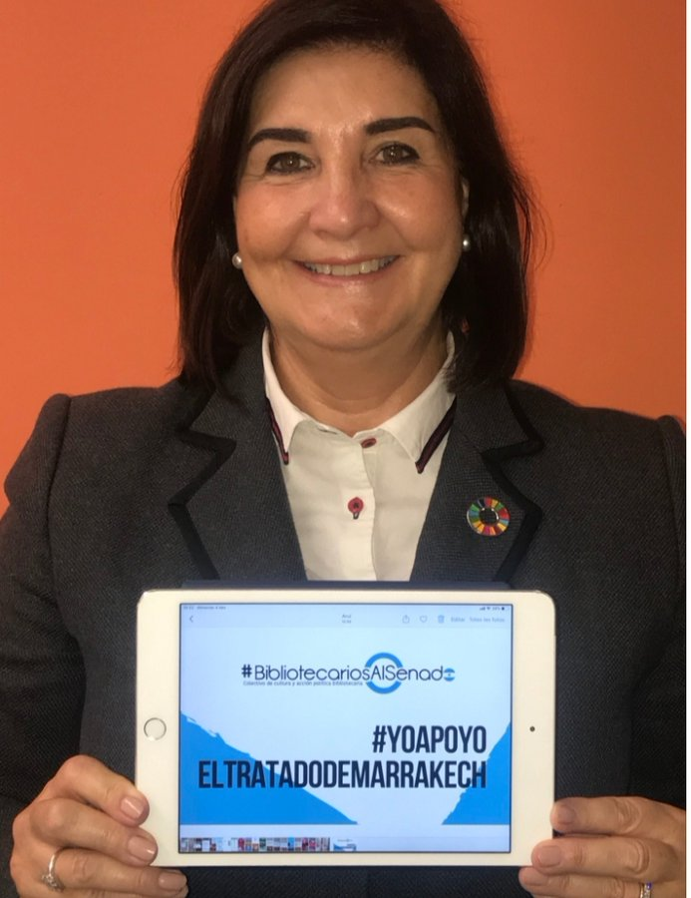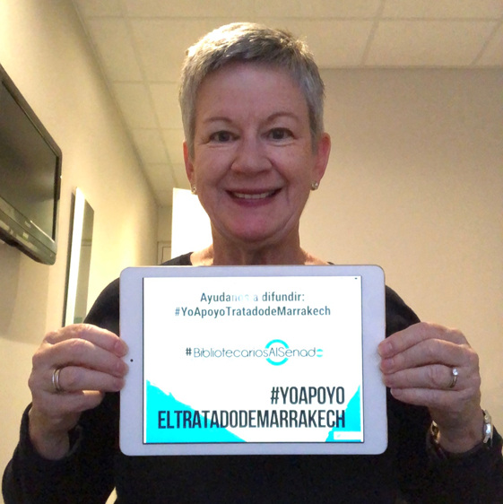
Pictures: Gloria Perez Salmeron and Christine Mackenzie (IFLA President 2019-2021) holding a tablet that says “I Support the Marrakech treaty” #YoApoyoElTratadoDeMarrakech

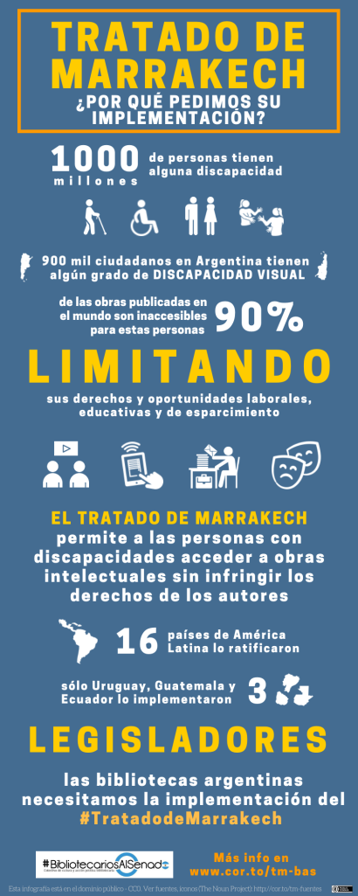 | Translation of the poster:  Marrakesh Treaty: Why do we ask for its implementation?  1 billion people have a disability.  900 thousand citizens in Argentina have some degree of visual impairment.  90% of the published works in the world are inaccessible for these people, limiting their rights and opportunities for work, education and recreation.  The Marrakesh Treaty allows people with disabilities to access intellectual works without infringing on the rights of the authors.  16 Latin American countries ratified it. Only Uruguay, Guatemala and Ecuador implemented it.  Lawmakers: Argentine libraries need the implementation of the #Marrakech Treaty.

By Virginia Ines Simon, Coordinator of the Observatory of the Marrakesh Treaty in Latin America / IFLA LPD Member

© IFLA LPD section, June 2020

