 | IFLA School Libraries Section  Satellite 2017, Wroclaw Poland  18 August 2017  9:00 – 18:00 | 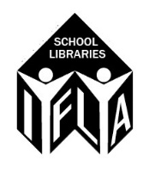

Content
The workshop will be aimed at the implementation of the 2nd edition of the School Library Guidelines.
The workshop consists of 6 elements
- Chapter 1 Mission and Purpose of a School Library
- Chapter 2 Legal and Financial Framework for a School Library
- Chapter 3 Human Resources for a School Library
- Chapter 4 Physical and Digital Resources of a School Library
- Chapter 5 Programs and Activities of a School Library
- Chapter 6 School Library Evaluation and Public Relations
There will be 3 sessions, so participants can follow the module of 3 chapters.
Venue
The Lower Silesian Pedagogic Library
Worcella 25-27, 11-400 Wrocław

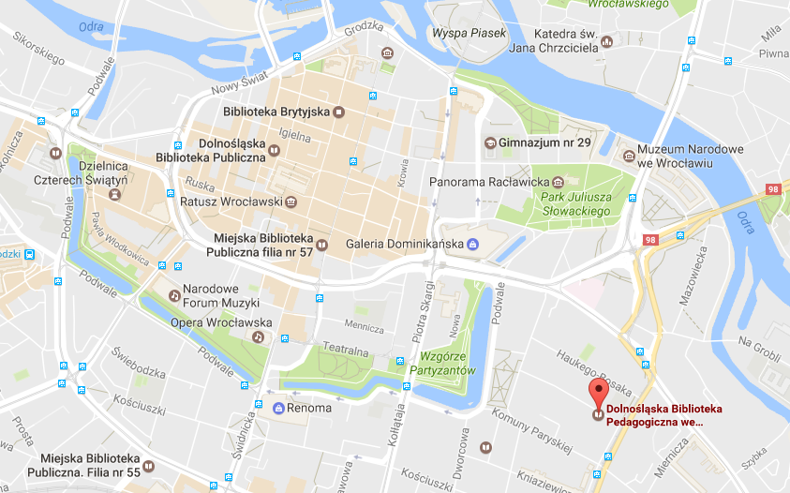
The Lower Silesian Pedagogic Library is Wroclaw’s main pedagogic library. It supervises the 27 pedagogic libraries in the Lower Silesian Voivodeship. Apart from a rich collection of books and magazines the library offers training for teachers and educational activities for pupils and students. The readers have access to computers and wi-fi. Our self-service reprographic equipment is of latest generation, as well as our automated library system (ALEPH). Library's rich collection of books (pedagogy, psychology, sociology, social sciences) e-books and the particularly interesting database of materials concerning the modern education and history of education are constantly updated.
The Lower Silesian Pedagogic Library is conveniently located in the city center. It only takes a 15-minute walk to reach the Main Railway Station and the Market Square.

The building is accessible for the disabled. It has two air-conditioned conference rooms and three training/didactic rooms (one air-conditioned, two furnished with PC for the pupils and teachers under training).
Homepage
Facebook
Google+
Google Maps
Pinterest
Youtube

Getting here:
Trains No. 0L, 5 or Buses No. 145, 146, go to/from the Central Train/Bus Station (Wrocław Główny) every 15-20 minutes. The entire journey takes approximately 5 minutes (depending on the traffic). Bus No. 106 goes from the Wrocław Airport every 20 minutes. The entire journey takes approximately 40 minutes (depending on traffic).
Buses No. 145, 146 go to/from Centennial Hall every 15-20 minutes. The entire journey takes approximately 10-15 minutes (depending on traffic). For a detailed timetable see: www.wroclaw.pl/rozklady-jazdy

Program
10:00 – 10:15 | Welcome | Local organizer  Lesley Farmer SLC Chair
10:15 – 10:45 | School libraries in Poland | To be announced
10:45 – 11:00 | Introduction to the 2nd edition of the School Library Guidelines | Dianne Oberg  Barbara Schultz-Jones
11:00 – 11:15 | Introduction to the modules of the workshop | Karen Gavigan
11:15 – 11:30 | Coffee/Thea break
11:30 – 12:45 | Modules  60 minutes in group and 15 minutes reporting
12:45 – 14:00 | Lunch
14:00 – 15:15 | Modules  60 minutes in group and 15 minutes reporting
15:15 – 15:45 | Coffee/Thea break
15:45 – 17:00 | Modules  60 minutes in group and 15 minutes reporting
17:00 – 17:15 | Summing up

Registration
There is no registration fee, but participants should register in advance via this form
Further information can be obtained via:
satellitewroclaw@gmail.com and albertkb@gmail.com

