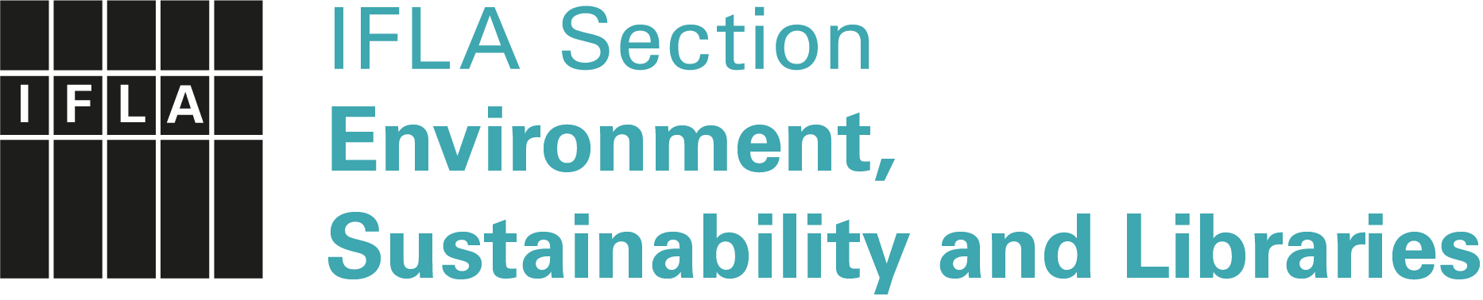

IFLA Green Library Award 2022

Application Form
Administered by ENSULIB, IFLA Section on Environment, Sustainability and Libraries
https://www.ifla.org/environment-sustainability-and-libraries
Sponsored by de Gruyter Publishing House

Submission title
Submission type | ( ) essay, ( ) video, ( ) poster, ( ) article, ( ) set of slides,  ( ) other: ______________________________________  Concerning ( ) an entire Green Library or  ( ) a Green Library Project
Submission language | ( ) English, ( ) Arabic*, ( ) Chinese*, ( ) German*, ( ) French*, ( ) Russian*, ( ) Spanish*  *English translation required
Type of library | ( ) Public, ( ) School, ( ) Academic, ( ) other: …………………
Single numbers of SDGs addressed
Surname(s), name(s)
Name of the library
Postal address
Email
Website
Abstract (up to 300 words, in English):

Please send your submission only electronically as an attachment, via Dropbox, WeTransfer etc. not later than 28 February 2022 to:
Dr. Petra Hauke, ENSULIB Secretary
Email: petra.hauke@hu-berlin.de

