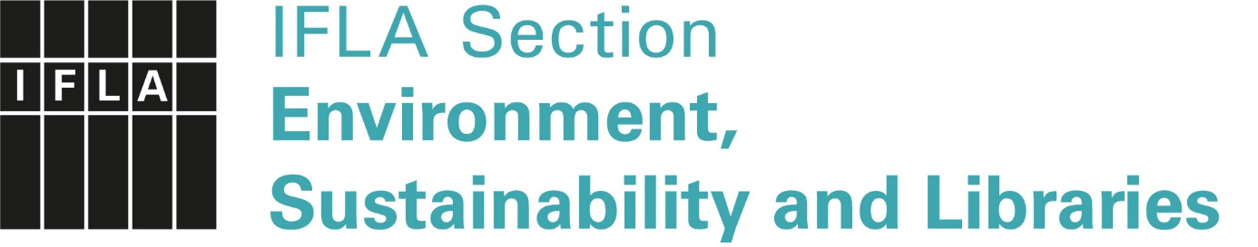
IFLA Green Library Award 2023
Self-evaluation form
December 2022
Please complete this self-evaluation form with care. English language is required.
This is a check list and short answers will suffice. Pay particular attention to those aspects of sustainability which are not a focus in the submission. The reviewers should gain a general impression of your library’s sustainability from the contents of this form.
This self-evaluation form alone is not a complete submission. A complete application form and submission are also required.
Submission title:
Name of the library:
City / Country:
Scope of sustainabilty |  |  | YES | NO
Environmental
Economic
Social
Significance |  |  | YES | NO
Local
National
Global
Innovative, climate smart initiatives and services: | What has been done: | Results, measurement*:
 | [Example:]  Seed library founded. | [Example:]  This is the first seed library in town.

Communication and community engagement: | What has been done: | Results, measurement*:
 | [Example:]  User participation and involvement. | [Example:]  The project was widely discussed and promoted as an example of successful community engagement.
The building’s carbon footprint – how emissions and consumption are decreased: | What has been done: | Results, measurement*:
 | [Example:]  The building’s energy efficiency has been increased by renovation 2020. | [Example:]  LED -lights, air condition renewed.  Solar panels.
Sustainable work practices: | What has been done: | Results, measurement*:
 | [Example:]  We follow the green office principles: recycling and sorting | [Example:]  Green office certificate
Additional relevant activities: | What has been done: | Results, measurement*:

* Results and measurements may be qualitative in nature (as in the examples), but if quantitative measurements are available, please indicate them.

