Read and delete! Trainers: If you edit this file, please change the file name to show
the region and date [YYYYMMDD]: IFLA_IAP_Topic2_RoleOfLibraries_Activity2.4_Worksheet_Region_YYYYMMDD
IFLA INTERNATIONAL ADVOCACY PROGRAMME
LIBRARIES, DEVELOPMENT, AND THE UN 2030 AGENDA
TOPIC 2: THE ROLE OF LIBRARIES IN THE UN 2030 AGENDA
ACTIVITY 2.4: HOW YOUR LIBRARY ALREADY CONTRIBUTES TO THE SDGs

INSTRUCTIONS
Refer to the IFLA Booklet Access and Opportunity for All and the IFLA handout Libraries can drive progress across the entire UN 2030 Agenda, and think about how your current library activities can be mapped to the SDGs and associated targets

Step 1: Make a list of the programmes and services your library offers
(or libraries in your country offer)

A programme might be training or classes that you offer at your library or across a city or country. It might be a series of classes, or a one-off event.

A service includes all of the materials, resources, technology and functions of the library online and as a safe physical space.

Programme | Objective of this programme
Example: ICT training for seniors | Example: To support digital inclusion amongst seniors so they can communicate with their family
Example: Storytime classes for babies and young children | Example: to support early literacy interventions

Services | Objective of this service
Example: Access to Open Access research | Example: to enable researchers to have the latest knowledge in their field
Example: The library as a physical community space, meeting rooms | Example: to make sure everyone has access to a safe space

Step 2: Review the list of SDGs and choose one or two key topics

There are 17 Goals and 169 targets. Identify one or two Goals that are most relevant to your library or association, or your country. This could be a Goal that, for example, your government has highlighted in their policies or the media. If one of the Goals is a priority for government they are more likely to commit resources and support to it.

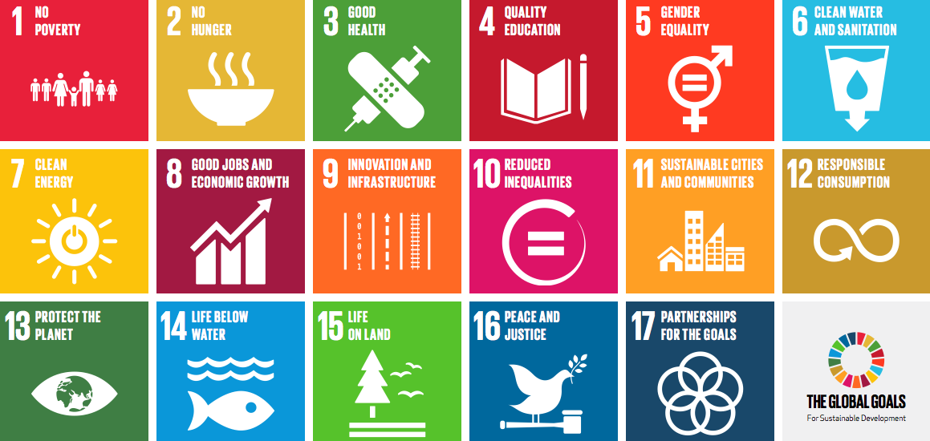

We have chosen these Goals: | We chose these Goals because:

Step 3: Using the list of programmes and services you made above, and the Goals you
chose, start to map the library’s activities against the Goals

The Sustainable Development Goals are very broad, and the targets within each Goal are more specific. In some cases, you might be able to identify a specific target that your programme or service supports. But it is more likely that you can support a more general Goal.

To build your message, try combining the Goal, activity, and objective:

Our library contributes to [Goal] by [programme or service] that supports [objective]

Goal | Library programme or service that supports this Goal | Message
Goal 4. Ensure inclusive and equitable quality education and promote lifelong learning opportunities for all | Storytime classes for babies and young children | Our library contributes to Goal 4 on quality education by providing storytime classes for babies and young children that supports early literacy interventions
Goal 9: Build resilient infrastructure, promote inclusive and sustainable industrialization and foster innovation | ICT training for seniors | Our library contributes to Goal 9 on innovation and infrastructure by providing ICT training for seniors that supports digital inclusion amongst seniors so they can communicate with their family

Step 4: Do you have evidence?
You can support your message with evidence about how effective your programme or service is. Local decision makers, community members and others will appreciate stories, statistics or other information that shows how meaningful your work is.

Goal | Library programme or service that supports this Goal | Message | Evidence
Goal 4. Ensure inclusive and equitable quality education and promote lifelong learning opportunities for all | Storytime classes for babies and young children | Our library contributes to Goal 4 on quality education by providing storytime classes for babies and young children that supports early literacy interventions | Examples: 150 children have attended this programme in 2016.  A survey of teachers found that children who participated in the programme before they started school showed improved reading skills than their peers.
Goal 9: Goal 9. Build resilient infrastructure, promote inclusive and sustainable industrialization and foster innovation | ICT training for seniors | Our library contributes to Goal 9 on innovation and infrastructure by providing ICT training for seniors that supports digital inclusion amongst seniors so they can communicate with their family | Examples: 50 seniors have participated in at least one class to learn how to use a computer or create a social media account.  One of the participants shared that she had moved to the country 10 years ago, and not been able to travel to her home country. Now with the skills gained at the library, she is able to email and talk with her family on a more regular basis.

Step 5: Share your message – tell everyone how your library contributes to the SDGs

Contact your national library association and share your messages with them – they need stories for their own advocacy work at the national level.

Share your messages in your own community: make posters in your library sharing your local messages and stories.

Some ideas for messages

https://sustainabledevelopment.un.org/post2015/transformingourworld

