Libraries on the move: reaching out to the less-fortunate and marginalized

Darrel Manuel O. Marco and Ann Grace B. Bansig
De La Salle Santiago Zobel School
Muntinlupa City, Philippines

The De La Salle Santiago Zobel School – Learning Resource Center (DLSZ-LRC), in the Philippines, launched its Bookmobile Project for more than two years now, as part of its mission to promote the love for reading and its long-term vision, which is to develop life-long learners.

The project is a collaboration between the Learning Resource Center and Social Action Office of the De La Salle Santiago Zobel School, the Zonta Club of Alabang, a soroptimist organization in the Philippines that helps send out-of-school youth to school and envisions life-long learning especially for those in the lower class and, the E-Zobel Foundation, a Non-Government Organization (NGO), based in Calatagan, Batangas, Philippines that also helps students and youth appreciate and eventually, value the love for reading and learning.

The project’s main objective is to reach out to our less-fortunate brothers by lending collapsible shelves, composed mainly of children’s books – fiction, general references and Filipiniana materials, into partner public schools and urban poor communities. After a month of loaning period to the partner institutions, the Bookmobile will then move to other beneficiaries. Some books will then be donated to the previous school or community to utilize as their own.

Additionally, the team behind the project creates learning activities that would further develop children’s interest and habits in reading. Activities such as storytelling, puppet shows, arts and crafts, kamishibai, etc. are done with the children every month.

For methodology, this study will utilize interviews with the beneficiaries regarding the impact of the project to their institution. Furthermore, it shall employ evaluation sheet and narrative reports including comments and feedbacks submitted by the beneficiaries.

The result of this study will help improve the services of the bookmobile project in terms of: 1. Policy of the project; 2. Expansion of collection; 3. Acquisition of new materials; 4. Additional manpower; 5. Collaboration with other organizations; and 6. Provision of learning activities.

I. Introduction
The Bookmobile Service is an on-going library outreach program implemented by the Learning Resource Center (LRC) of the De La Salle Santiago Zobel School, in coordination with the Social Action Office for partner public schools and urban poor communities, which started November 17, 2009.

Prior to the implementation of the project, the LRC raised funds by holding various book fairs in the campus and book shower campaigns to solicit donations from and impart the importance of the outreach project to the students.

In general, the Bookmobile is a mobile library in collapsible shelves that visit its partner public schools and communities located throughout the Southern parts of Metro Manila e.g. the cities of Muntinlupa, Parañaque, Las Piñas, and in Calatagan, Batangas. Additionally, in order to perk up the beneficiary’s insatiable thirst in reading, the LRC conducts a turnover ceremony that features library activities such as Book Talk, Storytelling, Puppet Shows, etc.

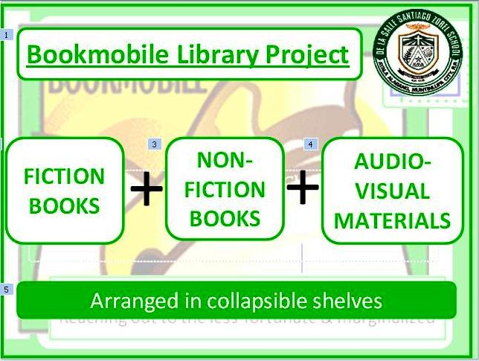

The Bookmobile carries fiction, non-fiction books for children including paperbacks, magazines and audiovisual materials. The books are acquired, processed and managed by the Learning Resource Center.

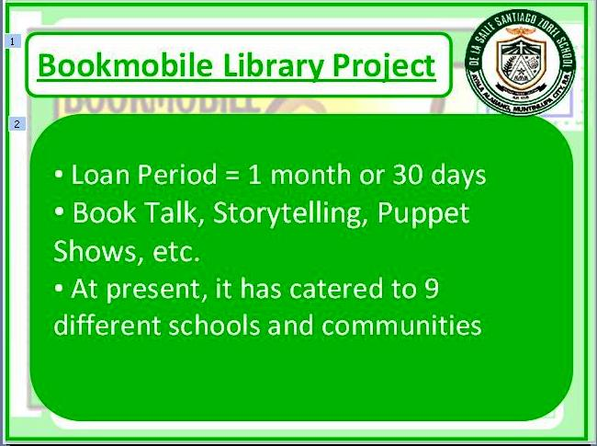

The books are loaned to participating schools / communities for a month. At the end of the loan period, the ‘teacher librarians’ or persons in charge, from the beneficiary school, collect and return the books to the DLSZ library for sorting, inventory and repacking.

The Bookmobile has also extended its services to partner communities last summer. The rationale behind is that instead of having the book collection stock in the libraries, the better option is to loan it to partner communities during the summer break.

The project is a great collaboration between the LRC and target public schools and partner communities, especially in its preparation and implementation. Collective discussion and decision-making are carried out to ensure effective feedback and implementation of the programme. The LRC personnel, the public school teachers and community volunteers executed constant evaluation to gauge the levels of user satisfaction of the services rendered.

At the end of every loan period, the beneficiaries prepare a closing program that shows the benefits gained from the Bookmobile service. The LRC, on the other hand, donates token library materials to the beneficiaries.

At present, the Bookmobile project has already catered to 9 schools in the South Metro Manila area and in Calatagan, Batangas. Since the different collapsible shelves contain different sets of reading materials, they are turned over between the abovementioned beneficiary schools. Additionally, schools may also request to be a part of the project given that they comply with the necessary requirements set in the project’s Memorandum of Agreement and Guidelines (MOA).
Organizational Profiles

De La Salle Santiago Zobel School – Learning Resource Center
The De La Salle Santiago Zobel Learning Resource Center primarily supports the institution’s instructional, curricular and co-curricular programs through an organized, relevant, and fast delivery of information. The library endeavors to contain the finest and most current technical and scientific information through collection development, modern computing, and state of the art facilities that encourage the acquisition of knowledge and the love of reading.
The Learning Resource Center plays an important role in the educational program of the school wherein the library resources constitute a fundamental part of the education of the students. Thus, the LRC expects to work continuously toward excellence in providing students and teachers with the necessary resources for teaching and learning.
The school envisions to form Christian Achievers for God and Country who live the Gospel values in the light of the Lasallian tradition of religio, mores and cultura. Bound by faith, enkindled with zeal, and committed to service, the learners acquire knowledge and skills for lifelong learning in a diverse and technologically changing global society.
As part of its outreach program, came the Book Mobile Project to supplement the lack of public and school libraries in the Philippines. Additionally, it aims to address insufficiency of budget allocated for books, libraries and its maintenance and operations.

De La Salle Santiago Zobel School – Social Action Office
The De La Salle Santiago Zobel School Social Action Office develops a sense of awareness on issues concerning children, realize the commonality and nurtures one’s sense of compassion towards youth-at-risk. It recognizes and appreciates the students’ role in the Lasallian mission by actualizing and intensifying their zeal for service with the poor and especially the children and the youth-at-risk.

Social Action Office is the one that raises awareness of the Lasallian community on local and national issues especially those that directly/indirectly affect the children and the youth. It also builds partnerships and strong linkages with people organization, government and non-government organizations, churches, schools and other organizations that share a common conviction for children and the youth-at-risk.

Social Action Office for its part in the Book mobile project identifies and coordinates the prospect beneficiaries of the program. Together with the LRC, they evaluate the needs of the partner schools. Moreover, they assist in the manpower needed for the project.

E-Zobel Foundation, Inc
The Enrique Zobel Foundation, Inc. is a non stock, non- profit organization whose founder was the late Don Enrique Zobel. He believed that “through education there is hope for a better life”. Taking this cue from the businessman-philanthropist, the Foundation continues to uphold quality public education system by focusing on five major program areas: school infrastructure development, teacher training, student health and nutrition, learning support and other special projects.
The Enrique Zobel Foundation aspires to sustain these programs and services and hopefully leave a mark of the founder’s enduring legacy. It envisions to commit itself in the transformation process of the Filipino poor and other disadvantaged sector of Philippine society.
The foundation is committed to help improve the quality of public education system; to provide the youth with the opportunity to experience hope that education brings; and to promote the well-being of the people and transform them into healthy, self-sufficient and productive members of society.
The foundation for its part in the Book mobile project coordinates with the partner public schools in the area of Calatagan, Batangas, southern province of the Philippines. Calatagan, Batangas is endeared to Don Enrique Zobel since it is his hometown.

Zonta Club of Alabang
Zonta Club of Alabang, which is under the umbrella of Zonta International, seeks to improve the legal, political, economic, educational, health and professional status of women at the local levels through service and advocacy. With the generosity and collective action of the members, they have supported projects in various areas within and around the city of Muntinlupa by providing local services, feeding programs, scholarships and fund raising which enable women and children to enrich and improve their lives.

The club started the involvement in the Book mobile project in 2011. Since then, they have been an active supporter of the project. They have provided additional book shelves and financial support for the expansion of the program.

II. The Project’s Objectives
The primary goal of the Bookmobile library is to provide outreach to children in the Public schools and underprivileged communities. As such, this project is set up to fulfil the following objectives:
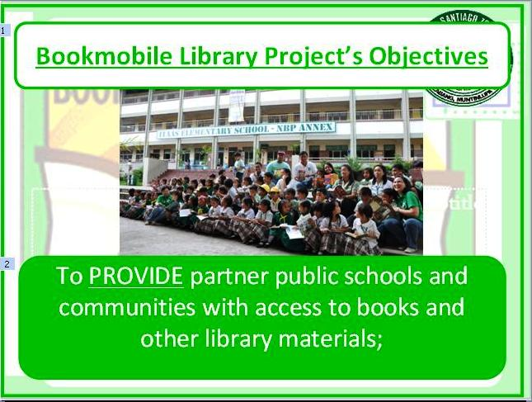

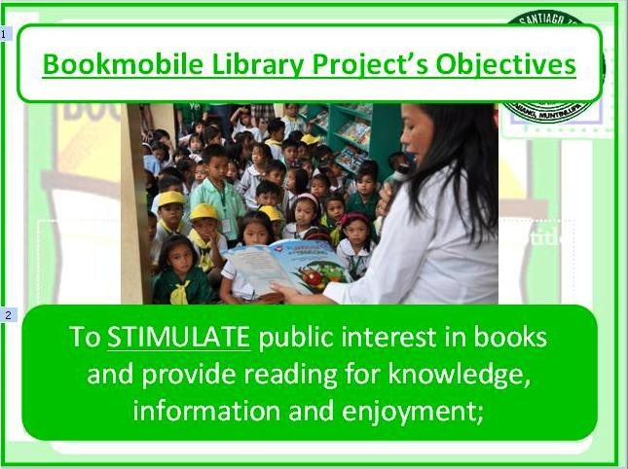
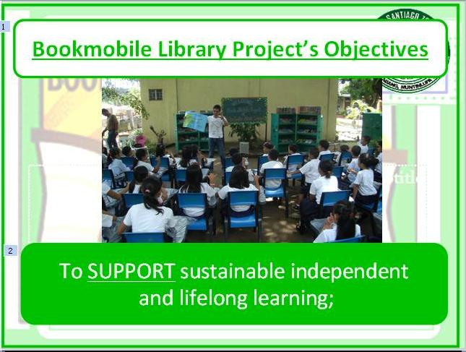

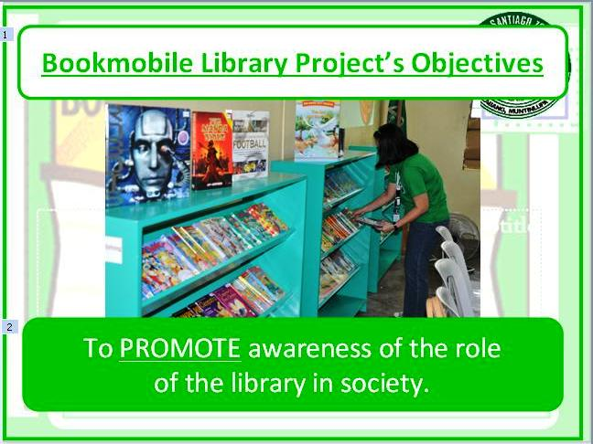

III. Beneficiaries
The schedule of the Bookmobile is set at the beginning of each school year and based on the priority level. The Bookmobile shall operate during the set schedule per year. At present, here are the partner school and communities that the Bookmobile library caters to:

1. Public Schools
1.1 Tunasan Elementary School
1.2 Alabang Elementary School
1.3 Buli Elementary School
1.4 Victoria Homes Elementary School
1.5 Itaas Elementary School
1.6 Cupang Elementary School
1.7 Santiago Zobel School, Calatagan Batangas
1.8 Upland School in Calatagan Batangas
2. Communities
2.1 Mary Mediatrix restoration Village Creeksite, UPS IV Subd.
Brgy. Marcelo Green, Parañaque City
2.2 Villa Paraiso, Sun Valley Parañaque City
2.3 St. Louie Talon 3 Talon, Las Piñas City

IV. The Bookmobile structure

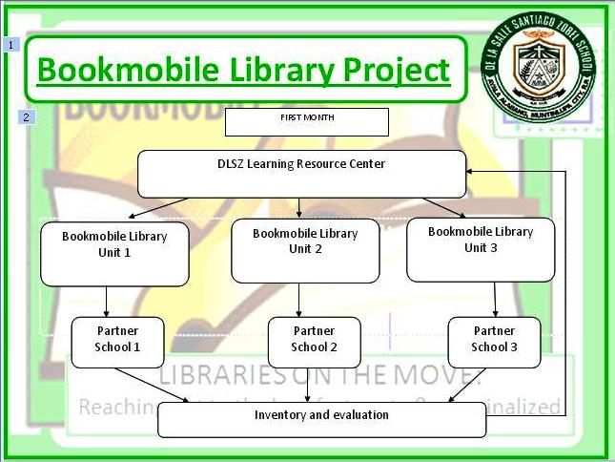

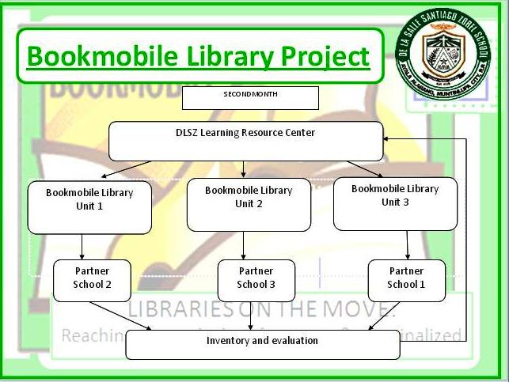

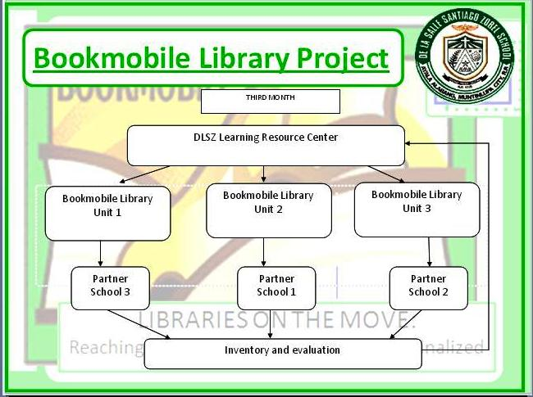
V. Evaluation Tools
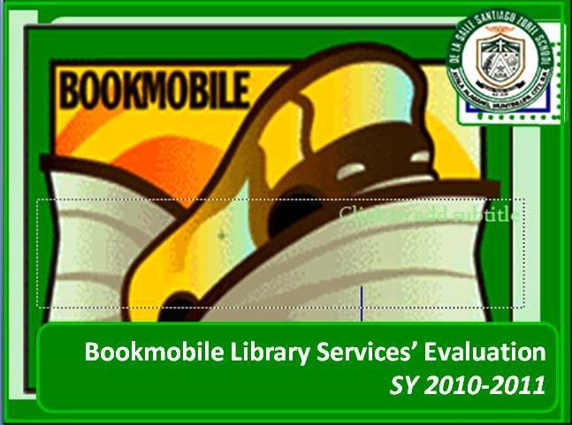

In order for the LRC to measure the impact of its Bookmobile library project, it implemented together with the Institutional Research Planning Office Head of DLSZ, a survey entitled “Bookmobile Library Services Evaluation” last February 28-March 18, 2011.

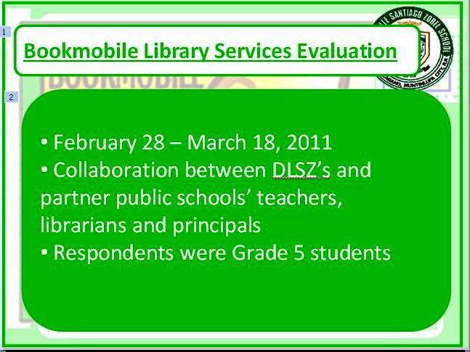

It was carried out in coordination with the school principals, librarians, and reading teachers of DLSZ and the beneficiary schools. The evaluation forms were distributed to Grade 5 students of the beneficiary schools. Samples were drawn from the whole population through random sampling.

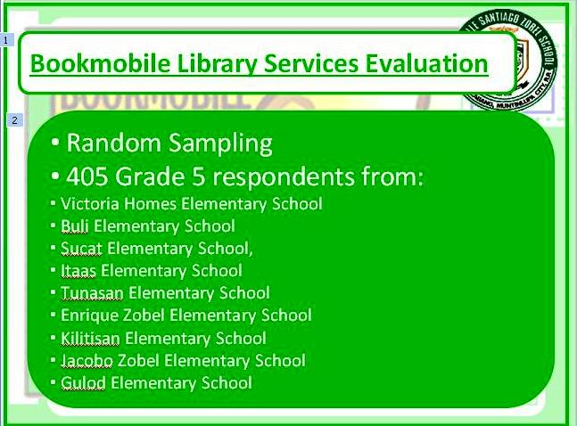

Among the respondents were students from Victoria Homes Elementary School, Buli Elementary School, Sucat Elementary School, Itaas Elementary School, Tunasan Elementary School, Enrique Zobel Elementary School, Kilitisan Elementary School, Jacobo Zobel Elementary School, and Gulod Elementary School.

Respondents answered the questionnaire consisting of two parts namely – Part I-Bookmobile services and Part II – Suggestions for improvement.

The survey asked the readers to rate how the Bookmobile library generally meets their needs in terms of services. Respondents were asked to rate their satisfaction on degrees of strongly agree, agree, uncertain, disagree and strongly disagree basis.

Overall, 405 completed survey forms were returned.

V. Results and Discussion
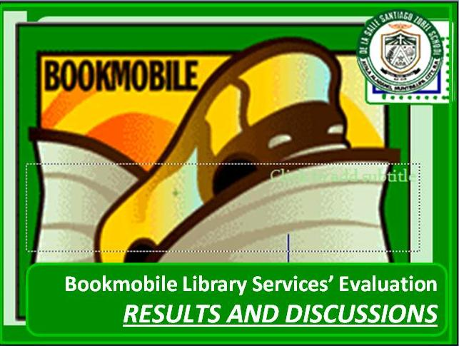

The Bookmobile Library User Satisfaction Results are as follows:

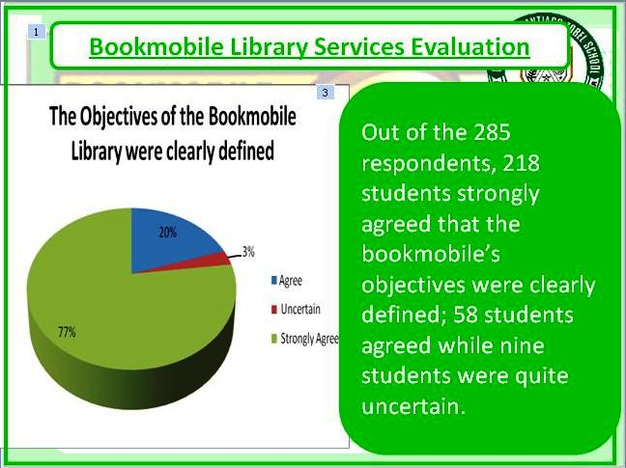
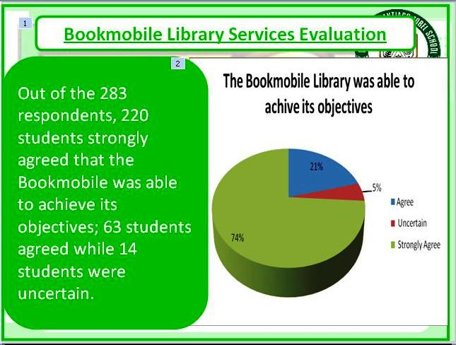

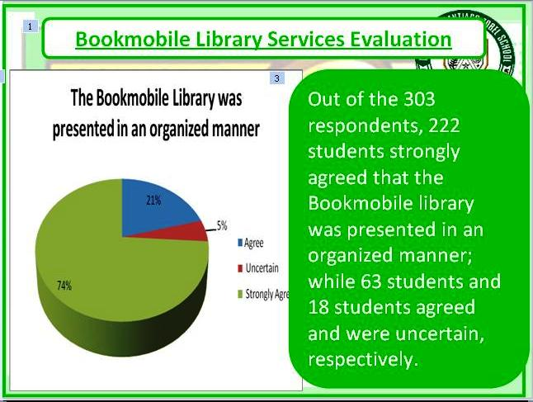

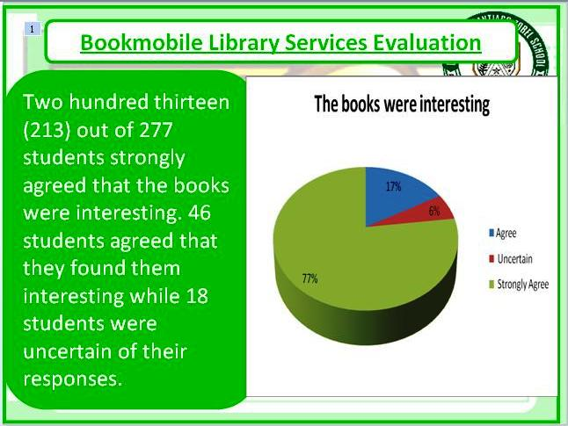

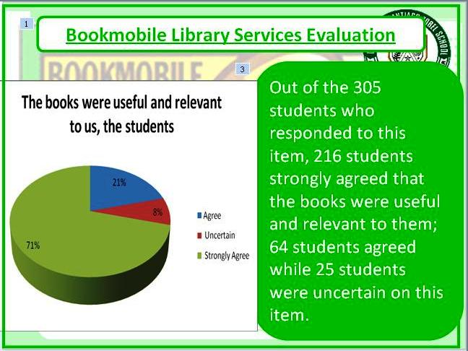

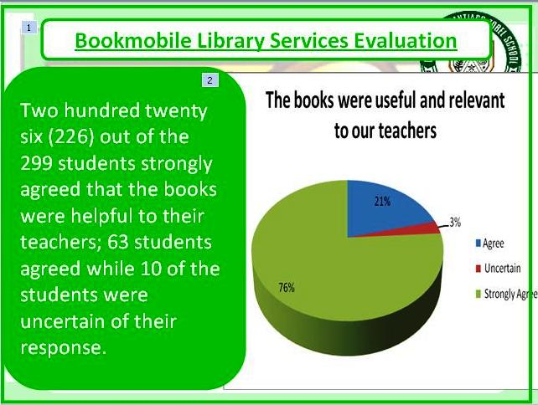

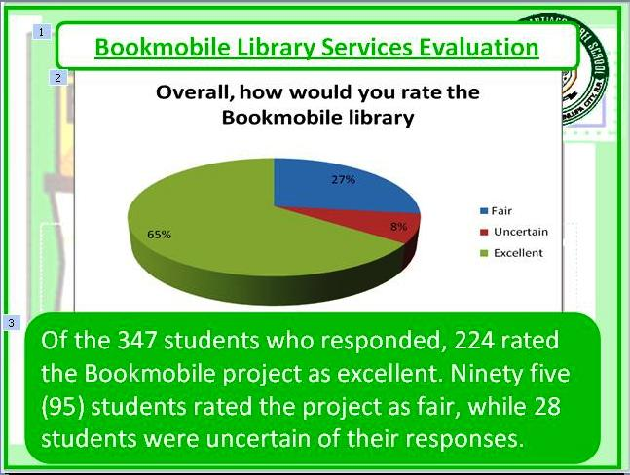
Part 2: Suggestions for improvement (copied verbatim)

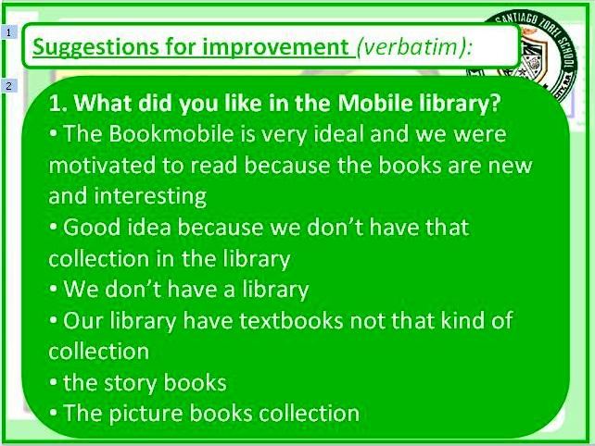

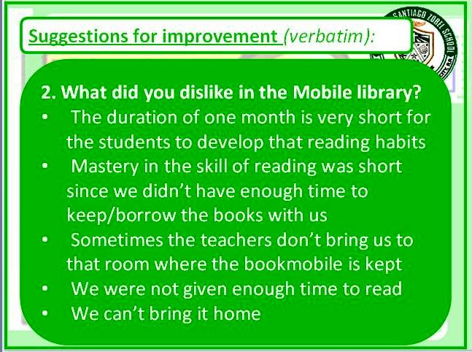
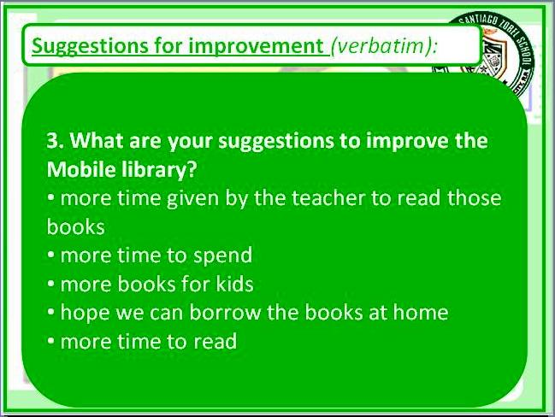

Discussion:

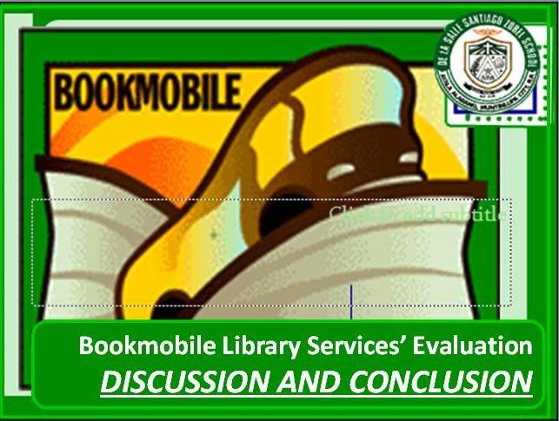
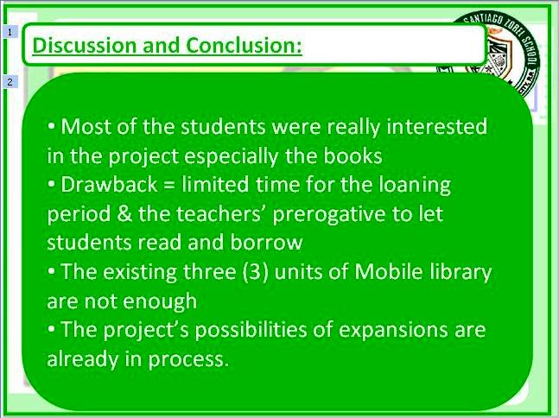

Most of the students were really interested in reading the books provided by the mobile library. The drawback, though, is the limited time the teachers give their students for reading time as leisure. Likewise, time is also of essence in loaning the Mobile library to its partner public schools. As much as the Learning Resource Center wants the students to enjoy the books more and develop reading habits, constraints in time and resources are at stake. Since the LRC also envisions catering to all of its beneficiaries, the existing three (3) units of Mobile library are not enough. On the part of the teachers, the prerogative to lend the books to their students is on them. The LRC tries to develop the Bookmobile as bigger as possible and possibilities of expansions are already in the process.

VI. Conclusion
Having met the objectives stated, there are still a couple of things to improve.

Based from the findings of the data gathered, the following conclusions and recommendations are drawn:
- As an on-going project of the library, the students in the public schools rated a “very satisfactory” mark by stating that they strongly agree with the services of the Bookmobile library


