PRESS RELEASE
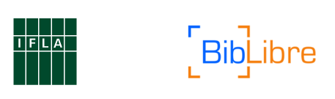
IFLA BibLibre International
Library Marketing Award

March, 2017
The IFLA Section on Management and Marketing in collaboration with our award sponsor Biblibre, announces the 14th IFLA BibLibre International Marketing award winners! This award honors organizations which implement creative, results-oriented marketing projects or campaigns.

We received 65 applications from 11 countries, in 5 languages
from all over the world!

[2017 Winner!] READay - Library of University of Science and Technology Beijing - China
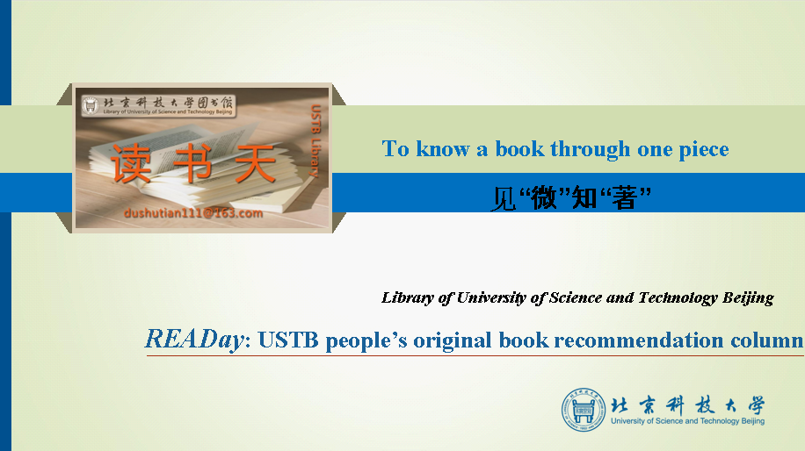
READay is reading promotion program of Library of University of Science and Technology Beijing. Every day, by twittering a selected book review and attractive paragraphs through our WeChat official account, READay helps to create a better reading environment on campus.

The library receives 2000€ cash award and airfare, lodging and registration for the IFLA World Library and Information Congress 83rd IFLA General Conference and Assembly 19–25 August 2017, Wrocław, Poland

[2nd place] Open Data Application Development Contest 2016 @ Shanghai Library - China

2016 Shanghai Library Open Data Application Development Contest collected excellent mobile application prototypes and service ideas based on Shanghai Library Genealogy Knowledge Database from the whole society. The event conveys the reflection and exploration that Shanghai Library has made on the transformation and innovation of public libraries in the big-data era
The library receives 1000€ cash award and airfare, lodging and registration for the IFLA World Library and Information Congress 83rd IFLA General Conference and Assembly 19–25 August 2017, Wrocław, Poland

[3rd place] Little Paradise Human Library - Wuhan University Library - China

Little Paradise Human Library is a project hosted by the library of Wuhan University and coordinated by Yuewei Literature Society, a student club in the campus. We strive to find individuals who have his or her own extraordinary experiences and present them as “books”, which are worth our reading, in ways of interviewing them as our guest talkers, “encoding” them with call numbers and making posters to introduce them to readers. And our philosophy is, and has always been, that everybody is a book and has his or her story that deserves reading.

The library receives 500€ cash

Among the 65 applicants, the jury has selected the 10 projects that it has found most inspirational. The following projects did not make it to the podium but deserve to be highlighted.

[Australia] Spotlight on Libraries x 3 - Sunshine Coast Libraries
[Canada] Open Access Week Campaign - UBC Library
[China] Utopia for Children' s Reading - Liaoning Provincial Library
[China] 2016 Shanghai Jiao Tong University Library Orientation: Micro Video - Shangai Jiaotong University Library
[China] WE READING (The Digital Reading Project of the Shanghai Library) - Shangai Library
[Russian Federation] See / Read / Listen - Boris Yeltsin Presidential Library
[Russian Federation] Country reading rooms invite friends - Khakas Republican Children's Library

Organizer
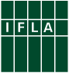
The International Federation of Library Associations and Institutions (IFLA) is the leading international body representing the interests of library and information services and their users. It is the global voice of the library and information profession with more than 1,300 members in 140 countries worldwide. The Headquarter is based The Hague/Netherlands.

The yearly IFLA International Marketing Award was initiated by the IFLA Section on Management and Marketing and is beeng since 2002. Now, the IFLA Section is a professional body, which currently comprises 25 library experts from all over the world, 10 of them are IFLA International Marketing Award jury members. Since 2016, the IFLA Biblibre International Marketing Award is supported by the French IT company.


Sponsored by
BibLibre is a provider that works with Open Source software because the company peaple believe it contribute to a community and freer world. Choosing BibLibre is primarily choosing a strong expertise in the library field and project management. It is trusting a provider chosen by more than 130 libraries or consortia of all sizes, ranging from the Resistance museum in the Massif Central, which manages 5,000 records to the University of Aix-Marseille, which manages more than 1, 5 million records for its 70,000 members. BibLibre is a french company, with customers all around Europe. Since 2016, has been cooperating with IFLA, providing financial support for the IFLA Biblibre International Marketing Award.
Contact for more information: iflajurymembers@googlegroups.com

