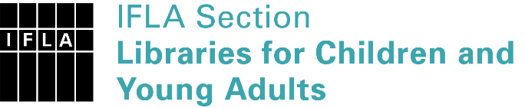 | Sister Libraries for Children & Young Adults’ Reading  Registration form
Timestamp | 25/02/2022 14:59:39
Name of participating institution | Biblioteca Popular "Coronel José Rodríguez"
Type of the library or institution | Public library
Name of contact person | Carolina Di Bert
Email of contact person | bibliocoronda@hotmail.com
Country | Argentina
Other contact details | Postal address: España 1815 (zip code 2240)  Alternative email: cadibert@hotmail.com  Facebook page: Biblioteca Popular "Coronel José Rodríguez"
Languages spoken by the staff | English, Spanish, Fluent English
Languages spoken and read by the children/young adult patrons | Spanish
Number of staff in the children and young adults section including employees and volunteers | 11-19
Current library programs for children and young adults | We hold literary workshops for children and have a special reading area for children and young adults.
Countries preferred for partnership | United States
Reasons for wanting a Sister Library partnership | Professional exchange of ideas and experiences, Joint promotions, campaigns, Professional continuining education, Communication, networking
Anything else you'd like to say | The Biblioteca Popular "Coronel José Rodríguez" was founded in 1912 and is the only public library in the city and surrounding towns. We would like to find a partnership in order to share ideas, experiences and activities as well as establish a special relationship with a sister library abroad.

