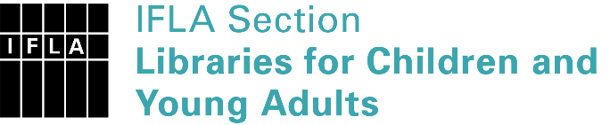 | Sister Libraries for Children & Young Adults’ Reading  Registration form
Timestamp | 07/06/2021 07:13:44
Name of participating institution | St Aloysius Primary School Library
Type of the library or institution | School library
Name of contact person | Jacqueline Wheadon
Email of contact person | jwheadon@saredan.catholic.edu.au
Country | Australia
Other contact details | PO Box 48R, Redan, Victoria 3350
Languages spoken by the staff | English
Languages spoken and read by the children/young adult patrons | English is the primary one
Number of staff in the children and young adults section including employees and volunteers | 1
Current library programs for children and young adults | Weekly visit to the Library of classes
Countries preferred for partnership | anywhere!
Reasons for wanting a Sister Library partnership | Professional exchange of ideas and experiences, Joint promotions, campaigns, Professional continuining education, Communication, networking
Anything else you'd like to say | I work one day a week in this small parish school, would be fantastic to connect with anyone else in a similar situation.

