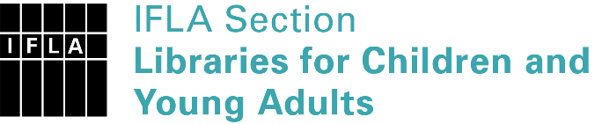 | Sister Libraries for Children & Young Adults’ Reading  Registration form
Timestamp | 07/05/2021 20:17:27
Name of participating institution | Centre de services scolaire de Montréal
Type of the library or institution | School library
Name of contact person | Lourdine Altidor Marsan
Email of contact person | altidormarsan.l@csdm.qc.ca
Country | Canada
Other contact details | 5100, rue Sherbrooke Est, Montréal, QC H1V 3R9
Languages spoken by the staff | French
Languages spoken and read by the children/young adult patrons | French
Number of staff in the children and young adults section including employees and volunteers | More than 20
Current library programs for children and young adults
Countries preferred for partnership | France, Belgique, Afrique, Finlande, Caraibes
Reasons for wanting a Sister Library partnership | Professional exchange of ideas and experiences, Joint promotions, campaigns, Professional continuining education, Improving language skills (staff or patrons), Communication, networking
Anything else you'd like to say

