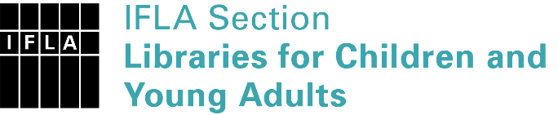 | Sister Libraries for Children & Young Adults’ Reading  Registration form
Timestamp | 07/02/2020 16:14:21
Name of participating institution | Sistema Nacional de Bibliotecas Públicas
Type of the library or institution | Public library
Name of contact person | Luz Yennifer Reyes Quintero
Email of contact person | luzyennifer@gmail.com
Country | Chile
Other contact details | https://www.bibliotecaspublicas.gob.cl/sitio/
Languages spoken by the staff | Spanish
Languages spoken and read by the children/young adult patrons | Español
Number of staff in the children and young adults section including employees and volunteers | More than 20
Current library programs for children and young adults
Countries preferred for partnership
Reasons for wanting a Sister Library partnership | Professional exchange of ideas and experiences, Joint promotions, campaigns, Professional continuining education, Improving language skills (staff or patrons), Communication, networking
Anything else you'd like to say

