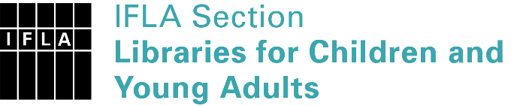 | Sister Libraries for Children & Young Adults’ Reading  Registration form
Timestamp | 18/02/2020 04:05:22
Name of participating institution | Cefepritad
Type of the library or institution | NGO, association
Name of contact person | KILUBA MUNDEKE Jowett
Email of contact person | Kilmund963@gmail.com
Country | Congo, Democratic Republic of the
Other contact details | WhatsApp: +243 97 79 55 281
Languages spoken by the staff | French
Languages spoken and read by the children/young adult patrons | Francais, Kiswahili
Number of staff in the children and young adults section including employees and volunteers | 6-10
Current library programs for children and young adults | Pas compris ici
Countries preferred for partnership | France, Suisse, Hollande, Belgique
Reasons for wanting a Sister Library partnership | Professional exchange of ideas and experiences, Joint promotions, campaigns, Professional continuining education, Communication, networking
Anything else you'd like to say | Besoin des livres divres pour le gout des lecteurs

