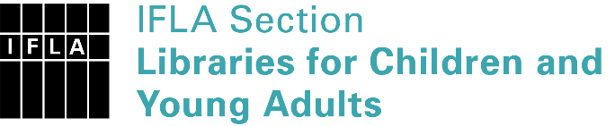 | Sister Libraries for Children & Young Adults’ Reading  Registration form
Timestamp | 09/02/2023 13:19:13
Name of participating institution | Knihovna Kroměřížska, o.p.
Type of the library or institution | Public library
Name of contact person | Lucie Čevelová
Email of contact person | cevelova@knihkm.cz
Country | Czech Republic
Other contact details | www.knihkm.cz , kasparkova@knihkm.cz ,
Languages spoken by the staff | English
Languages spoken and read by the children/young adult patrons | English, German
Number of staff in the children and young adults section including employees and volunteers | 2-5
Current library programs for children and young adults | We do every month. Now it is a valentins competition. Teens write a love letters.
Countries preferred for partnership
Reasons for wanting a Sister Library partnership | Professional exchange of ideas and experiences, Joint promotions, campaigns, Professional continuining education, Improving language skills (staff or patrons), Communication, networking
Anything else you'd like to say

