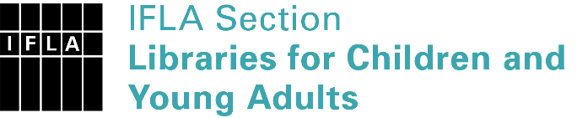 | Sister Libraries for Children & Young Adults’ Reading  Registration form
Timestamp | 04/06/2020 21:54:05
Name of participating institution | UNIDAD EDUCATIVA BRITÀNICO INTERNACIONAL
Type of the library or institution | School library
Name of contact person | Irene Garcìa Laveda
Email of contact person | igarcia@britanico.edu.ec
Country | Ecuador
Other contact details | http://www.britanico.edu.ec/nuestro-colegio/biblioteca-eduardo-garcia-espinoza/
Languages spoken by the staff | English, Spanish
Languages spoken and read by the children/young adult patrons | español, inglès, francès, italiano
Number of staff in the children and young adults section including employees and volunteers | 2-5
Current library programs for children and young adults | IB Programs
Countries preferred for partnership | España, Inglaterra, Italia, Francia,Canadà, EEUU, Chile, Mèxico, Argentina, Australia, India
Reasons for wanting a Sister Library partnership | Professional exchange of ideas and experiences, Joint promotions, campaigns, Professional continuining education, Communication, networking
Anything else you'd like to say | Me encanta la idea de que nuestra biblioteca pueda formar parte de Bibliotecas Hermanas IFLA. Muchas gracias

