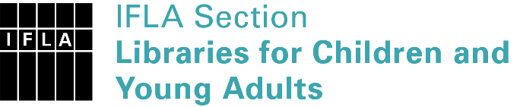 | Sister Libraries for Children & Young Adults’ Reading  Registration form
Timestamp | 26/04/2020 19:41:00
Name of participating institution | Helsinki City library
Type of the library or institution | Public library
Name of contact person | Janne Mikkonen
Email of contact person | janne.mikkonen@hel.fi
Country | Finland
Other contact details
Languages spoken by the staff | English
Languages spoken and read by the children/young adult patrons | English
Number of staff in the children and young adults section including employees and volunteers | More than 20
Current library programs for children and young adults
Countries preferred for partnership
Reasons for wanting a Sister Library partnership | Professional exchange of ideas and experiences, Communication, networking
Anything else you'd like to say

