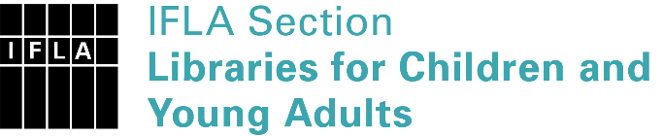 | Sister Libraries for Children & Young Adults’ Reading  Registration form
Timestamp | 07/04/2022 13:55:47
Name of participating institution | Ylöjärven kaupunginkirjasto (Ylöjärvi Public Library)
Type of the library or institution | Public library
Name of contact person | Annika Lång
Email of contact person | annika.lang@ylojarvi.fi
Country | Finland
Other contact details | https://www.ylojarvi.fi/kirjasto
Languages spoken by the staff | English, Finnish, Swedish
Languages spoken and read by the children/young adult patrons | Mostly Finnish
Number of staff in the children and young adults section including employees and volunteers | 2-5
Current library programs for children and young adults | Story times for toddlers, library lessons for school children, themed book bags, book club for tweens...
Countries preferred for partnership | USA, Nordic countries, any other
Reasons for wanting a Sister Library partnership | Professional exchange of ideas and experiences, Communication, networking, Sharing ideas and cultural knowledge
Anything else you'd like to say | We are looking forward to meeting new people in the library world!

