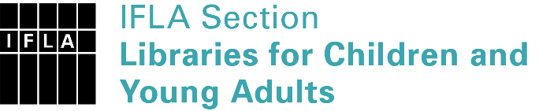 | Sister Libraries for Children & Young Adults’ Reading  Registration form
Timestamp | 19/01/2020 11:53:42
Name of participating institution | Katerini Public Library
Type of the library or institution | Public library
Name of contact person | Panagiotis Triantafyllidis
Email of contact person | triantafyllidispanagiotis@hotmail.com
Country | Greece
Other contact details | dlibrarykaterini@hotmail.com
Languages spoken by the staff | English, Italian, Greek
Languages spoken and read by the children/young adult patrons | English, Greek
Number of staff in the children and young adults section including employees and volunteers | 2-5
Current library programs for children and young adults
Countries preferred for partnership | Italy
Reasons for wanting a Sister Library partnership | Professional exchange of ideas and experiences, Joint promotions, campaigns, Professional continuining education, Improving language skills (staff or patrons), Communication, networking
Anything else you'd like to say

