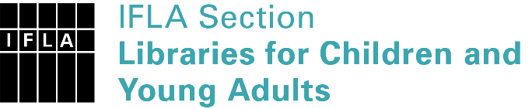 | Sister Libraries for Children & Young Adults’ Reading  Registration form
Timestamp | 08/10/2019 15:04:54
Name of participating institution | Ashok Kumar Aasrani
Type of the library or institution | Private library
Name of contact person | Ashok Kumar Aasrani
Email of contact person | ashokaasrani007@gmail.com
Country | India
Other contact details | 3/972 malviya nagar Jaipur 302017 rajasthan INDIA
Languages spoken by the staff | English, Hindhi
Languages spoken and read by the children/young adult patrons | Hindhi / English
Number of staff in the children and young adults section including employees and volunteers | 2-5
Current library programs for children and young adults
Countries preferred for partnership
Reasons for wanting a Sister Library partnership | Professional exchange of ideas and experiences
Anything else you'd like to say

