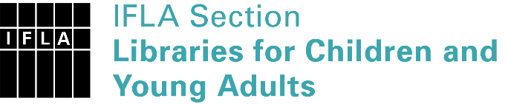 | Sister Libraries for Children & Young Adults’ Reading  Registration form
Timestamp | 23/08/2021 00:59:00
Name of participating institution | KVIIIT JHALWA ALLAHABAD
Type of the library or institution | School library
Name of contact person | MADHURI RAWAT
Email of contact person | rawat.madhuri2@gmail.com
Country | India
Other contact details | librarykviiitjhalwa@gmail.com
Languages spoken by the staff | English
Languages spoken and read by the children/young adult patrons | English and Hindi both
Number of staff in the children and young adults section including employees and volunteers | 11-19
Current library programs for children and young adults
Countries preferred for partnership
Reasons for wanting a Sister Library partnership | Professional exchange of ideas and experiences, Joint promotions, campaigns, Communication, networking
Anything else you'd like to say

