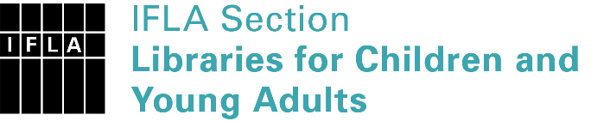 | Sister Libraries for Children & Young Adults’ Reading  Registration form
Timestamp | 14/07/2020 09:34:54
Name of participating institution | Pustakalana Children's Library
Type of the library or institution | NGO, association
Name of contact person | Puti Ceniza
Email of contact person | pustakalanalibrary@gmail.com
Country | Indonesia
Other contact details | www.pustakalanalibrary.wordpress.com
Languages spoken by the staff | English, Indonesian
Languages spoken and read by the children/young adult patrons | Indonesian, English
Number of staff in the children and young adults section including employees and volunteers | 6-10
Current library programs for children and young adults | Storytelling, Book Club, Parents Club, Art and Crafts
Countries preferred for partnership | United States, Australia, Singapore, Netherlands
Reasons for wanting a Sister Library partnership | Professional exchange of ideas and experiences, Joint promotions, campaigns, Professional continuining education, Improving language skills (staff or patrons), Communication, networking
Anything else you'd like to say | I hope the sister library program can make benefecial aspects for both libraries

