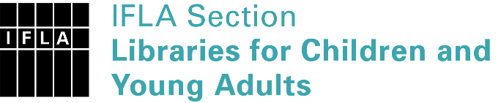 | Sister Libraries for Children & Young Adults’ Reading  Registration form
Timestamp | 9-2-2021 13:19:13
Name of participating institution | Itabashi Central Library
Type of the library or institution | Public library
Name of contact person | Tomoko SASAOKA
Email of contact person | ehon@city.itabashi.tokyo.jp
Country | Japan
Other contact details | postal address: 4-3-1 Tokiwadai Itabashi-ku Tokyo 174-0071 JAPAN  email: chuolib@city.itabashi.tokyo.jp  website: https://www.city.itabashi.tokyo.jp/library/index.html
Languages spoken by the staff | English, Japanese
Languages spoken and read by the children/young adult patrons | Japanese, English
Number of staff in the children and young adults section including employees and volunteers | 6-10
Current library programs for children and young adults | Story telling, Making picture books by children, Exhibition of foreign picture books ("Bologna Book Fair in Itabashi")
Countries preferred for partnership | Italy
Reasons for wanting a Sister Library partnership | Communication, networking

