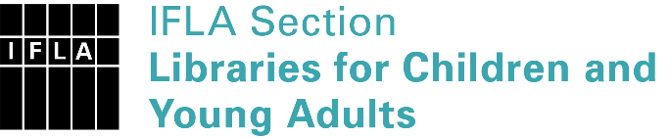 | Sister Libraries for Children & Young Adults’ Reading  Registration form
Timestamp | 06/11/2021 15:25:14
Name of participating institution | Biblioteca Comunale di Bagno di Romagna
Type of the library or institution | Public library
Name of contact person | Chiara Tosi
Email of contact person | bblioteca@bagnodiromagnaturismo.it
Country | Italy
Other contact details
Languages spoken by the staff | Italian
Languages spoken and read by the children/young adult patrons | Italian
Number of staff in the children and young adults section including employees and volunteers | 1
Current library programs for children and young adults | Letture ad alta voce
Countries preferred for partnership
Reasons for wanting a Sister Library partnership | Professional exchange of ideas and experiences, Joint promotions, campaigns, Communication, networking
Anything else you'd like to say

