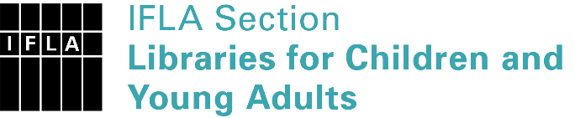 | Sister Libraries for Children & Young Adults’ Reading  Registration form
Timestamp | 16/12/2021 19:48:59
Name of participating institution | Biblioteca Salaborsa Ragazzi - Comune di Bologna - Settore Biblioteche
Type of the library or institution | Public library
Name of contact person | Nicoletta Gramantieri
Email of contact person | nicoletta.gramantieri@comune.bologna.it
Country | Italy
Other contact details | Piazza del Nettuno, 3 - 40124, Bologna - https://www.bibliotecasalaborsa.it/ragazzi/ - https://it-it.facebook.com/bibliotecasalaborsa
Languages spoken by the staff | English, Italian
Languages spoken and read by the children/young adult patrons | Italian, English, Arabic, Spanish, French, Bangla, Urdu, Albanian, Japanese, etc.
Number of staff in the children and young adults section including employees and volunteers | 11-19
Current library programs for children and young adults | Biblioteca Salaborsa Ragazzi has a collection of over 70,000 materials for children and young people in 100 different languages. Most materials are available to be borrowed. It has dedicated spaces for babies, children, young people and adolescents. It carries out events to promote reading, the collections and the library for schools and free users: read alouds, musical activities for babies, meetings with authors, workshops of audio and video editing, coding and robotics, role-playing games, it promotes and runs a reading group for young people and adolescents, it offers training for educators, teachers, librarians on literature for children and adolescents. It develops reading promotion projects in partnership with schools and other institutions dealing with children's and adolescents' culture.
Countries preferred for partnership | Japan
Reasons for wanting a Sister Library partnership | Professional exchange of ideas and experiences, Joint promotions, campaigns
Anything else you'd like to say

