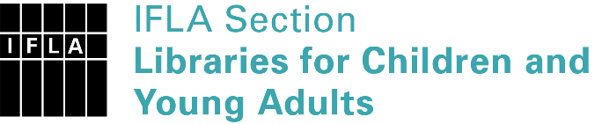 | Sister Libraries for Children & Young Adults’ Reading  Registration form
Timestamp | 30/10/2019 11:28:03
Name of participating institution | Nazarbayev Intellectual School of Physics and Mathematics in Kostanay
Type of the library or institution | School library
Name of contact person | Anara Abisheva
Email of contact person | Abisheva_A@ksr.nis.edu.kz
Country | Kazakhstan
Other contact details | https://www.facebook.com/Library-NIS-Kostanay-354709544729559/?eid=ARDEEvXJNQsImjcRQoL_6n0bcuqLWgEw0lcVob8NrSiIP_Tn9EVlzm4pcDaEF1QKy84aTRgfIinMZGR6
Languages spoken by the staff | English, Russian, Kazakh, Korean
Languages spoken and read by the children/young adult patrons | English, Russian, Kazakh
Number of staff in the children and young adults section including employees and volunteers | 2-5
Current library programs for children and young adults | "100 books is the program during which students needs to read 100 book in 5 years. Starting from grade 7 till the grade 12. According to that project students have 1 reading day every week.  Memoro - project about peoples who made history of our country. For example, people who participated in the Second World war."
Countries preferred for partnership | Does not matter
Reasons for wanting a Sister Library partnership | Professional exchange of ideas and experiences, Improving language skills (staff or patrons), Communication, networking
Anything else you'd like to say

