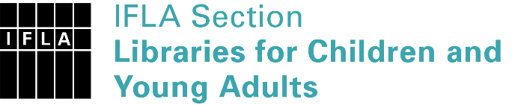 | Sister Libraries for Children & Young Adults’ Reading  Registration form
Timestamp | 9-18-2021 15:00:32
Name of participating institution | Koshu City Katsunuma Library
Type of the library or institution | Public library
Name of contact person | Keiko AOYAGI
Email of contact person | pdc01171@nifty.com
Country | Japan
Other contact details | 1034-1, Shimoiwasaki, Katsunuma-cho, Koshu-shi, Yamanashi, 409-1313, Japan  http://www.lib-koshu.jp/lib/katsunuma/  katsunuma@lib-koshu.jp
Languages spoken by the staff | English, Japanese
Languages spoken and read by the children/young adult patrons | Japanese
Number of staff in the children and young adults section including employees and volunteers | 2-5
Current library programs for children and young adults | 1) Storytime for babies & toddlers,  2) Children's book club,  3) Library guide tours for school children  4) Storytime with craft workshop  5) Author/ Illustrator visit
Countries preferred for partnership | any
Reasons for wanting a Sister Library partnership | Professional exchange of ideas and experiences, Joint promotions, campaigns, Professional continuining education, Communication, networking

