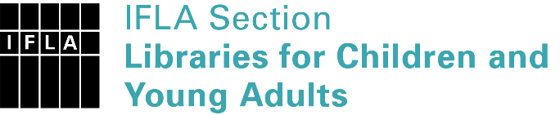 | Sister Libraries for Children & Young Adults’ Reading  Registration form
Timestamp | 05/07/2021 19:01:01
Name of participating institution | Girls Rising Malawi
Type of the library or institution | NGO, association
Name of contact person | Hastings Phiri
Email of contact person | hastingsphiri34@yahoo.com
Country | Malawi
Other contact details | The Director, Girls Rising Malawi, P.O. BOX 176, Mzimba MALAWI. WhatsApp +265886283023.
Languages spoken by the staff | English
Languages spoken and read by the children/young adult patrons | English
Number of staff in the children and young adults section including employees and volunteers | 11-19
Current library programs for children and young adults | Yes
Countries preferred for partnership | MALAWI
Reasons for wanting a Sister Library partnership | Professional exchange of ideas and experiences
Anything else you'd like to say | Book donation for schools

