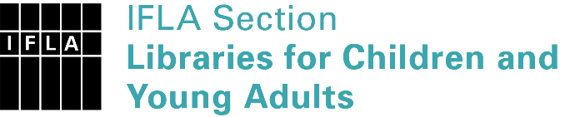 | Sister Libraries for Children & Young Adults’ Reading  Registration form
Timestamp | 07/03/2023 12:19:38
Name of participating institution | Hill crest college/ Alma
Type of the library or institution | School library
Name of contact person | Oseghale Sampson
Email of contact person | tushigucci@gmail.com
Country | Nigeria
Other contact details
Languages spoken by the staff | English
Languages spoken and read by the children/young adult patrons | English
Number of staff in the children and young adults section including employees and volunteers | 1
Current library programs for children and young adults | Book club
Countries preferred for partnership | USA, England, UAE, Ghana, South Africa, Kenya, Uganda, Rwanda, China, Russia
Reasons for wanting a Sister Library partnership | Professional exchange of ideas and experiences, Professional continuining education, Communication, networking,
Anything else you'd like to say | Would love books donations as well to my library down here in Nigeria, Calabar, Cross River State, West Africa, Africa.

