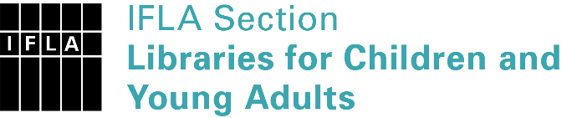 | Sister Libraries for Children & Young Adults’ Reading  Registration form
Timestamp | 08/02/2019 18:55:54
Name of participating institution | Bjerke videregående skole
Type of the library or institution | School library
Name of contact person | Inés Taaje
Email of contact person | ines.taaje@osloskolen.no
Country | Norway
Other contact details
Languages spoken by the staff | English
Languages spoken and read by the children/young adult patrons | Norwegian, English, Arabic,Turkish
Number of staff in the children and young adults section including employees and volunteers | 1
Current library programs for children and young adults
Countries preferred for partnership | Turkey, Middle Eastern countries,
Reasons for wanting a Sister Library partnership | Professional exchange of ideas and experiences, Professional continuining education, Communication, networking
Anything else you'd like to say

