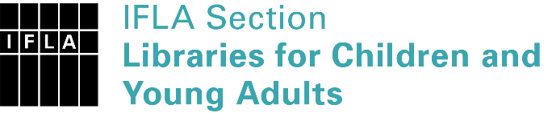 | Sister Libraries for Children & Young Adults’ Reading  Registration form
Timestamp | 27/04/2023 09:56:21
Name of participating institution | Scoala Gimnaziala nr.1 Cernica
Type of the library or institution | School library
Name of contact person | Matei Adrian
Email of contact person | cdiscoalacernica@gmail.com
Country | Romania
Other contact details | Str. Traian nr.19, Cernica, jud. Ilfov, Romania  https://www.facebook.com/CDIScoala1Cernica/
Languages spoken by the staff | English, Romanian
Languages spoken and read by the children/young adult patrons | Romanian, English
Number of staff in the children and young adults section including employees and volunteers | 2-5
Current library programs for children and young adults | What ideas in books. Robotics club. Little journalists.
Countries preferred for partnership | From anywhere
Reasons for wanting a Sister Library partnership | Professional exchange of ideas and experiences, Joint promotions, campaigns, Professional continuining education, Improving language skills (staff or patrons), Communication, networking
Anything else you'd like to say | I look forward to starting the collaboration

