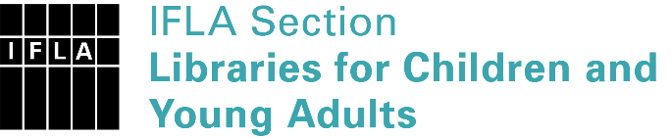 | Sister Libraries for Children & Young Adults’ Reading  Registration form
Timestamp | 27/01/2023 15:49:37
Name of participating institution | Russian State Library for Young Adults
Type of the library or institution | Public library
Name of contact person | Maria Alekseeva
Email of contact person | alekseeva@rgub.ru
Country | Russia
Other contact details | 4 build. 1 B. Cherkizovskaya 107061 Moscow Russia, https://rgub.ru/ , https://www.youtube.com/rgubru
Languages spoken by the staff | English, Russian, German, Bulgarian, Serbian, Korean
Languages spoken and read by the children/young adult patrons | Russian, English, French, German, Spanish, other
Number of staff in the children and young adults section including employees and volunteers | More than 20
Current library programs for children and young adults | Youth Week of Digital Technologies  Library Night  Reading Youth Council  Reader’s Award  Comics and visual culture programmes  Special collection of YA books from different countries  Inclusive programmes and events  Volunteering initiatives for young people  Podcasts  Multimedia E-Book History Museum
Countries preferred for partnership | Any
Reasons for wanting a Sister Library partnership | Professional exchange of ideas and experiences, Joint promotions, campaigns, Professional continuining education, Improving language skills (staff or patrons), Communication, networking
Anything else you'd like to say | The RSLYA is one of the eight federal-level libraries located in Moscow; a modern multimedia space with rich collection, latest technical equipment, comfortable and welcoming design and numerous services and programmes for young users (target age group 14-30); acts as an informational, educational and consulting centre for all young adult libraries as well as other public libraries serving young people in Russia.

