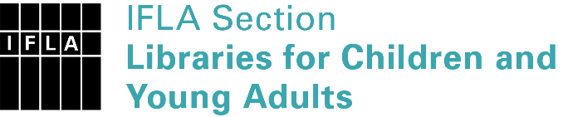 | Sister Libraries for Children & Young Adults’ Reading  Registration form
Timestamp | 16/03/2023 19:47:41
Name of participating institution | Belgrade City Library
Type of the library or institution | Public library
Name of contact person | Jasna Brkic
Email of contact person | brkicjasna011@gmail.com
Country | Serbia
Other contact details | https://www.facebook.com/decjabiblioteka.zmaj , https://bgb.rs/en/ , zmaj_bgb@yahoo.com
Languages spoken by the staff | English, Italian
Languages spoken and read by the children/young adult patrons | Serbian
Number of staff in the children and young adults section including employees and volunteers | 2-5
Current library programs for children and young adults | Creative writing; Storytelling for kids and parents; Saturday in the Library; Micro Bit programming; Meet the Writer; And Now Some Music (kids performing); Yes, we clay; Tell me a story - brick by brick (making LEGO stories), etc.
Countries preferred for partnership | Croatia, Italy, Finland, Estonia, Sweden, Iceland, France, Belgium, Spain, Sweden, Czech Republic
Reasons for wanting a Sister Library partnership | Professional exchange of ideas and experiences, Joint promotions, campaigns, Professional continuining education, Communication, networking
Anything else you'd like to say

