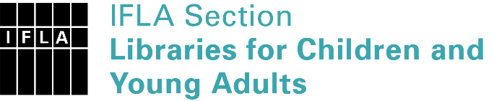 | Sister Libraries for Children & Young Adults’ Reading  Registration form
Timestamp | 07/07/2021 12:26:40
Name of participating institution | Tshepangone Monchonyane
Type of the library or institution | NGO, association
Name of contact person | Tshepangone Monchonyane
Email of contact person | tmonchonyane@yahoo.com
Country | South Africa
Other contact details | Tshatsha Monchonyane f.B, Mmabatho Unit 12, 3946, 2735,
Languages spoken by the staff | English
Languages spoken and read by the children/young adult patrons | English & Setswana
Number of staff in the children and young adults section including employees and volunteers | 2-5
Current library programs for children and young adults | Reading clubs
Countries preferred for partnership | South Africa and USA
Reasons for wanting a Sister Library partnership | Professional exchange of ideas and experiences, Joint promotions, campaigns, Professional continuining education, Improving language skills (staff or patrons), Communication, networking, Getting our reading materials to the public as well as an Author&ensure reading and African language is spoken
Anything else you'd like to say | Partnership & growth

