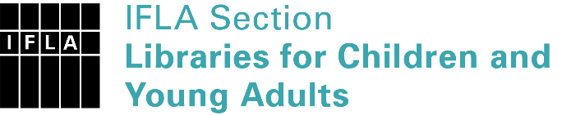 | Sister Libraries for Children & Young Adults’ Reading  Registration form
Timestamp | 01/01/2022 19:08:03
Name of participating institution | Biblioteca J.M. Colubi (IES Albero, Alcalá de Guadaíra, Seville, Spain)
Type of the library or institution | School library
Name of contact person | Alberto Zambrana Ramírez
Email of contact person | albertozambrana@iesalbero.es
Country | Spain
Other contact details
Languages spoken by the staff | English, Spanish, Italian
Languages spoken and read by the children/young adult patrons | Spanish, English
Number of staff in the children and young adults section including employees and volunteers | More than 20
Current library programs for children and young adults
Countries preferred for partnership | English-speaking countries
Reasons for wanting a Sister Library partnership | Professional exchange of ideas and experiences, Communication, networking
Anything else you'd like to say | We would like to get information about the possibilities of creating a partnership with other school libraries that might potentially be interested in establishing a partnership with our school

