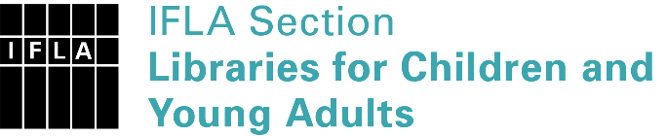 | Sister Libraries for Children & Young Adults’ Reading  Registration form
Timestamp | 12/03/2020 11:39:12
Name of participating institution | British Book Centre
Type of the library or institution | Public library
Name of contact person | Veronika Charskaia-Boiko
Email of contact person | veroniquechb@gmail.com
Country | Russia
Other contact details | britishbookcentre@gmail.com
Languages spoken by the staff | English, Russian
Languages spoken and read by the children/young adult patrons | Russian, English
Number of staff in the children and young adults section including employees and volunteers | 2-5
Current library programs for children and young adults | Annual English Children's Festival; Readings and workshop for children
Countries preferred for partnership | UK, USA
Reasons for wanting a Sister Library partnership | Professional exchange of ideas and experiences, Joint promotions, campaigns, Communication, networking, Cooperation, common projects
Anything else you'd like to say

