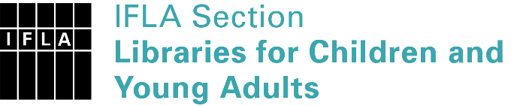 | Sister Libraries for Children & Young Adults’ Reading  Registration form
Timestamp | 14/01/2021 16:17:13
Name of participating institution | Huntcliff Secondary School
Type of the library or institution | School library
Name of contact person | Cassie Lawrence
Email of contact person | clawrence@slc.rac.sch.uk
Country | United Kingdom
Other contact details | Saltburn Learning Campus, Marske Mill Lane, Saltburn, TS12 1HJ
Languages spoken by the staff | English
Languages spoken and read by the children/young adult patrons | English, studying Spanish
Number of staff in the children and young adults section including employees and volunteers | 1
Current library programs for children and young adults | The library is currently undergoing refurbishment and obviously with a UK lockdown there are not many students at present. Hoping to initiate book clubs, graphic novel clubs and other programmes once things return to some form of normality.
Countries preferred for partnership | Spanish-speaking
Reasons for wanting a Sister Library partnership | Joint promotions, campaigns, Improving language skills (staff or patrons)
Anything else you'd like to say

