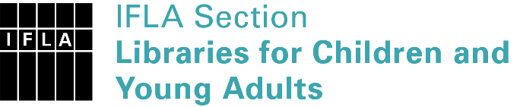 | Sister Libraries for Children & Young Adults’ Reading  Registration form
Timestamp | 09/12/2019 12:46:37
Name of participating institution | Kingsdale Foundation School - London
Type of the library or institution | School library
Name of contact person | Mihaela Buibas
Email of contact person | mhiy_me@yahoo.com
Country | United Kingdom
Other contact details | Address: Alleyn Park, Dulwich, SE21 8SQ London UK  E-mail: library@kingsdale.southwark.sch.uk
Languages spoken by the staff | English, French, Spanish, Romanian
Languages spoken and read by the children/young adult patrons | English, French, Spanish
Number of staff in the children and young adults section including employees and volunteers | 2-5
Current library programs for children and young adults | Reading challenges  Creative Writing competitions  Author Events  Manga Club  Book Club  Pupil Librarian program  Southwark Book Awards shadowing
Countries preferred for partnership
Reasons for wanting a Sister Library partnership | Professional exchange of ideas and experiences, Joint promotions, campaigns, Professional continuining education, Improving language skills (staff or patrons), Communication, networking
Anything else you'd like to say

