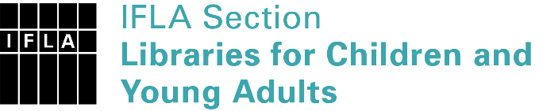 | Sister Libraries for Children & Young Adults’ Reading  Registration form
Timestamp | 27/01/2023 04:23:54
Name of participating institution | Nederland Community Library District
Type of the library or institution | Public library
Name of contact person | Elektra Greer
Email of contact person | egreer@nedlib.org
Country | United States (USA)
Other contact details | https://nederland.colibraries.org/
Languages spoken by the staff | English
Languages spoken and read by the children/young adult patrons | English
Number of staff in the children and young adults section including employees and volunteers | 2-5
Current library programs for children and young adults | Many and we have begun and International Library Exchange with Bibliotheek van Zeeland in the Netherlands
Countries preferred for partnership | Netherlands, Zeeland Library
Reasons for wanting a Sister Library partnership | Professional exchange of ideas and experiences, Joint promotions, campaigns, Professional continuining education, Improving language skills (staff or patrons), Communication, networking, We are starting an International Student Homestay Exchange program between our two libraries
Anything else you'd like to say | We would love any resources you can provide for us

